Dr Alec Shepley, University of Lincoln

Conference Paper

Yet to be determined: practicing space and site. Overlapping concepts of drifting, drawing and ideated idiocy as tools for social interaction and cultural reimagining.

------------------------------------------------------------------------------------------------------------

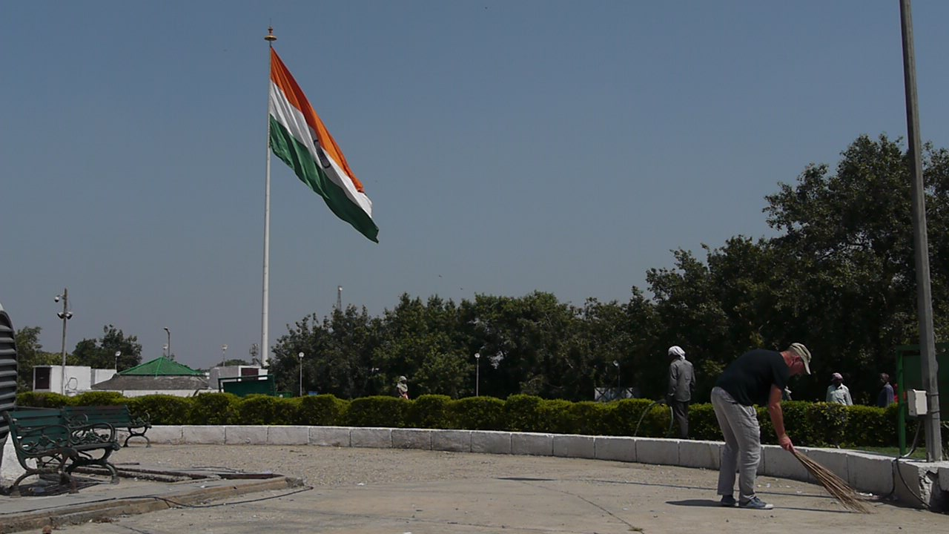

------------------------------------------------------------------------------------------------------------

Drawing Conversations: reflecting upon collective and collaborative drawing experiences
Conference, Coventry University, 4th December 2015

So, I’m sitting on the doorstep of the hotel side door, thinking of thresholds - marginal spaces that provide the kind of ambiguity I need to practice, to disperse, to encounter, to act – not standing for anything certain but renegotiating a relationship with audience; testing out work that is perhaps not “of art” (Duchamp, M. 1913, 105). I pick up on a kind of creative energy found in such settings as abandoned buildings, building sites, cracks, gutters, vacant lots, wind and dust, clefts and fissures, and the crumbling pavement beneath my feet - they offer a useful metaphor for my (our?) certain state of being.

Marcel Broodthaers wrote: "The definition of artistic activity occurs, first of all, in the field of distribution" (Crow, 1996 177). According to Daniel Kunitz (2011) the lesson of such earlier efforts in 1960s where art challenged context, is that if you want to disrupt the understanding of what art is you need to alter how it gets to its audience (see Figure 1) and somehow rupture its first (physical) and second (conceptual) frames (Kosuth, 1977).

This paper explores the nature and characteristics of a kind of ad hoc (drawing) practice that emerged during a short residency in Delhi in the autumn of 2014 together with an unofficial offshoot of the main residency programme – a sort of escape. I am reflecting on the possibilities of a practice at the interstices between the individual and the collective, between purpose and play – a kind of non-place. This space is not yet a place, or at least if it once was a place, it has somehow lost its place within the master-plan and is slowly falling away from its institutional configuration (see Figure 2).

The broader project contextualizes the continued value of drawing as an ad hoc, semi-structured method, alongside the tendencies amongst a number contemporary artists re-examining the status of the art object and questioning its position as highly valued, unique commodity-component as we enter the Age of the Anthropocene.

For the sake of context, the paper very briefly touches upon artists incorporating their own labour and that of others as the artwork in relation to traditional forms of object creation for market exchange. The paper will consider the value of ad-hocism and purposeful purposelessness as strategies for developing new approaches to drawing, opening new directions for practice research as an aid to reimaging cultural sites in neglected urban settings such as Delhi (see Figure 3).

The paper will reflect on the nature and value of specifically improvisational drawing and contouring practices which involved street encounters, sweeping and drifting through the city following the cracks, contours and tears within the urban fabric. Reference is made to precedents in art concerning the function of labour within artistic outputs; problematizing the relationship between art and capital; provisionality; the lasting document; and drawing as a social practice.

In the autumn of 2013 there was an open call for speculations from artists, curators, writers, architects, cultural practitioners and activists for the re-imagination of spaces and cultural infrastructure in Delhi. Raqs Media Collective, the Delhi-based artistic and curatorial collective, invited proposals for the imaginative rethinking of unused public spaces and cultural infrastructure in Delhi. The call was a provocation for artists and cultural practitioners to rediscover the city’s cultural and artistic potential through imaginative transformations and the result was a series of conversations initiated by artists from all over the world congregating in Delhi.

My project A Place of Impossibility was among the 25 submissions invited to exhibit their full proposals in the exhibition in New Models for Common Ground at Mati Ghar (Mud House), at the Indira Gandhi National Centre for the Arts (IGNCA) February 2014 as part of INSERT2014 curated by Raqs Media Collective (see Figure 4). Artists included Anagram Architects, Atom Collective, Yao Jui-Chung and Ivane Franke to name but a few.

INSERT2014 was an international contemporary art exhibition presented by the INLAKS Shivdasani Foundation, and supported by the Goethe Institute, New Delhi, and also by the India Foundation for the Arts, Bangalore. The trigger for the series was an invitation that Raqs received from INLAKS Shivdasani Foundation. At that time, they had just inaugurated the Sarai Reader ’09, a nine-month-long exhibition organised in collaboration with the Devi Art Foundation that dealt with what the future art scene in Delhi could be.

The Raqs Media Collective, selected Delhi as the site for INSERT for both conceptual and logistical reasons. Delhi is where the collective was founded in 1992 and has been based ever since. For Azad Shivdasani, chairman of INLAKS Shivdasani Foundation and the sponsor for this event, the idea was to see how an international show of contemporary art would fare in Delhi, after he came across one in Los Angeles. The main concern for Shivdasani, however, was that the event should be socially relevant. This is reflected in the kind of artists who were invited to be a part of it, such as the Taiwanese artist Yao Jui-Chung, from Taipei who presented Energies of Derelict Buildings as part of INSERT and has for the last two decades been fascinated by abandoned buildings, and those that have been built but never used (Ali 2014). Referring to one such recent work at Meliwan Resort on Shanyuan Bay, Taitung County where construction work started on the project in 2004, then ceased in 2007, and finally resumed in 2011, Yao said:

“Derelict buildings can naturally make for a good metaphor, a symbol for a certain state of mind, as our circumstances and our background can be seen in a similar way – as derelict buildings pending redevelopment or reconstruction. Derelict buildings provide a kind of creative energy that can be harnessed by artists” (Yao, J-C. 2010).

My own project in New Models for Common Ground speculated on a conceptual reimagining of two sites selected from the list put forward by Raqs Media Collective, namely Palika Bazaar Park on Connaught Place, and the abandoned office building known locally as Skipper Tower in Delhi (see Figures 13-19). Speculative street encounters, activities involving drawing, talking and writing, walks or happenings, were all proposed as a way to add the artist directly into the spatio-temporal mix, and experience the selected sites, encounter those people who lived and worked there, detailing the process using methods such as drawing, writing, photography and video etc. as appropriate.

Skipper Tower, located outside the metro station of Barakhambha Road, is a disputed property and has come to symbolize for many, the image of modernity in the form of a ‘ruin from the future’. This empty tower block currently stands alone and silent amongst many busy office spaces. The possession of this fourteen floor abandoned building currently rests under the Claims Commissioner, by the order of the Supreme Court of India. Although there was no further information found about this building at the time of writing this paper, the site in its present state of ruins and abandonment was seen by the project curators Raqs, as definitely one that could fuel micro engagements, as major events might be problematic due to the restrictions over ownership (see Figure 16).

The second site chosen for the project was Palika Bazaar and Palika Park on Connaught Place, Delhi. This park (and if you include the Bazaar) is one of the most popular public places of Delhi. This park attracts people from all walks of life: from homeless vagabonds to office workers, from college students to compulsive loners and many others besides. Connaught Place, popularly knows as CP is known not only for its nostalgic historicity and impressive built heritage, but also for the sheer vitality of changing urban life with all its fullness and diversity (see Figure 15).

Apart from the sheer terror and exhilaration I felt as an initial response to the scale of the place, I was struck by the heat, the constant noise and movement, and the breezes that stirred the trees and brightly coloured fabrics and flags, as I made my first drifts through the surrounding districts. I was drawn along on dizzying walks contouring architectural ‘ley lines’ of the crescents.

Benjamin wrote, the bazaar is the last hangout of the flâneur and I was set on inserting myself here with my sweeping brush, meandering through the spaces and contouring the intersecting lines which divide and subdivide the city’s lots, towards negating my existence (Benjamin, W. 2002, 12).

I walked slowly – like a tortoise – interested. I breathed consciously. Experiencing at such a slow, tortoise like pace contrasted with the effects of a large, fast moving city, the popular park busy with people from all walks of life, and served to foreground the large edifice of the modern office block void of people and produced many ad hoc micro-engagements with local people, visitors and groups of tourists milling around in the mix.

Although a very lively place, with large numbers of people present at any given time of the day the area is in decline and the infrastructure is in a state of decay. One of the curatorial aims of INSERT2014 was to “inaugurate a rethinking of ‘place’ in contemporary art as an active presence, and the foregrounding of the poetics of usage as a vital axis of art’s inhabitation with life and its potential” (Bagchi, Narula and Sengupta 2014, 10).

The project that I proposed for these sites was situated therefore within this broader context and included myself as an actor of a nomadic and fragmented practice, with an aim to occupy spaces seemingly void of artistic activity.

By inserting myself this way as a means to subvert and affect rhetorical frameworks and structures, to reimagine these spaces – or at least their potential to be re-imagined through artistic engagement and seemingly the flimsiest of plans. This is important, as the idea behind INSERT2014 was that of acting as a “provocation for artists and cultural practitioners to discover and propose ideas that can be leveraged, adapted and transformed to lay the foundations for a distinct and dynamic art and culture scene” (ibid 2014, 10). The point of departure for this event, therefore, is not an artwork but a provocation. However, given the history and context of the location, its current condition and the potential for my status as an artist to be perceived as an unwanted intrusion i.e. being ‘parachuted’ in to an area to engage in some kind of development activity, I decided to adopt ‘a point of departure’ as my main focus of activity and to escape – also to enact in a public setting for the first time the private, post-working day studio procedure – of sweeping the floor. I have, over the years developed certain working methods and habits that are attendant to practice but have hitherto outside. But rather than co-opt them within practice, I am speculating on their co-opting me! To maintain a form of escape. As Einstein wrote:

“To raise new questions, new possibilities, to regard old questions from a new angle, requires creative imagination and marks real advances in science”. (Einstein, A. 1938, 92).

Through the series of drifts through the proposed sites in Delhi, my proposal was to experience current conditions, exploring and documenting any apparent dilapidations and deteriorating institutional frameworks. The intention was “to invert the notion of ruin and reveal its positive and creative potential [to] pave the way for renewal and change” (Shepley 2014, 90-91). Through enacting this process of street cleaning – I would be effectively drawing in the dirt – I would encounter physical manifestations of the incomplete, unfinished maintenance and failings in the institutional fabric and form a visual language remarking on the present condition.

Using a research grant awarded for the project, I travelled to Delhi in September 2014 and over a period of several days enacted three street cleaning Dérives at three co-located sites in New Delhi: Palika Park; Skipper Tower; and Connaught Place.

In Enactments #1, #2 and #3 I am engaged in the act of sweeping the selected sites Connaught Place, Palika Park and Skipper Tower. At first glance these may seem like pointless acts, however I am exploring escape opportunities; what Gordon Matta-Clarke has referred to as metaphoric voids, gaps, left-over or undeveloped spaces where where you stop to tie your shoelaces. In other words, these are the places that are just interruptions in your own daily movements (Matta-Clarke 1974, 34).

Enactments #1, #2 and #3 were acts of contouring where I swept the paths (both designed routes and ad hoc ‘user experienced’ short cuts worn across the grass), cracks, back alleys, open doors and gateways of these evocative cultural sites. This work followed on from previous similar projects for example at Kilmahew in Scotland and other locations; following the psycho-geographic lines and shapes in my path, sensually sweeping the brush along the grooves, gutters and pavements of the selected sites (see Figures 10-12).

The (even more) unofficial project or offshoot comprised a set of fabric squares taped down onto the marble pavements which make up the crescents of Connaught Place. These pavements, worn into smooth, often slightly concave surfaces show the mark of countless people – office workers, travellers, tourists, beggars, pilgrims and the like, and I wondered how I could make a drawing of that. Or rather how could they make the drawing? So, following a kind of process based on observed phenomena and random selection, I ‘posted’ horizontally, special fabric designed for the job onto the various locations I had chosen. Over time passersby made their mark as they passed over the small sqaure on the floor. At first, when new and white, these squares formed a kind of obstacle, a hazard to go around, but with the unstoppable flow this caution was overtaken by the sheer pressure of numbers and the squares were soon obliterated – or in my eyes – made! Some remained in situ as I left for the UK, but obviously in a poor state of repair, some were removed by officials and I myself removed this one to bring home (see Figures 25-28).

The area around Connaught Place has an even stronger resonance for me now – it is a space that was once part of a Utopian master plan - institutionally cared for but perhaps now more feral space, slipping through the now worn municipal order and re-occupied by chance (see Figures 13-16).

Through these acts of marking and erasing, doing and undoing, this interplay becomes the maxim of the process. Surface is caressed – the material (dust) is the medium and pavement the substrate.

Given the reaction of the people I encounter in practicing the city like this, this spatial practice seems to serve as a temporary sign transmitting a ridiculous and yet occasionally moving presence in and amongst the proposed sites. It is the application of an aesthetic of regular experience to encounters in a wider field of action.

The project focused on architecture of the site and surface as a metaphor for our own psychological condition as humans, confronting the viewer with fragmentation and an incomplete project that perhaps is within our nature to shy away from. In this new work however, an attempt was made to put into reverse the negative stereotypes of neglect - to invert it and create the potential for a more positive metaphor by cleaning, where art has become more like a system or operation. The viewer is immersed in a set of visual relationships that subconsciously he or she is aware of, to create allegories, new meanings and to foreground the creative potential of the fragment in a process of renewal and redefinition. But that may sound too static - I’m thinking of ‘doing words’ – verbs – and thinking about my own version of Richard Serra’s verb list (see Figure 3).

The writings of Italo Calvino, in particular his book Invisible Cities, and principally the sections about the cities of Leonia and Sophronia, have also influenced this new work. The accidental viewer on the street of Delhi or visitor to Kilmahew would witness a figure steadily and progressively sweeping his way around, attempting to fulfil a seemingly impossible blueprint referred to by the inhabitants of Invisible Cities. The visual narrative conjures the street cleaners who are welcomed like angels to the city, and who “engage in their task of removing the residue of yesterday's existence in a respectfully silent ritual that inspires devotion” (Calvino 1979, 91). This is perhaps because once things have been discarded nobody really wants to have to think about them anymore:

“Nobody wonders where, each day, they carry their load of refuse. Outside the city, surely; but each year the city expands, and the street cleaners have to fall farther back. The bulk of the outflow increases and the piles rise higher, become stratified, extend over a wider perimeter. Besides, the more Leonia's talent for making new materials excels, the more the rubbish improves in quality, resists time, the elements, fermentations, combustions. A fortress of indestructible leftovers surrounds Leonia, dominating it on every side, like a chain of mountains” (Calvino 1979, 91).

In the book, as in the project, the reader/viewer is compelled to reflect on the ultimate outcomes of such accumulations of debris as an outcome of daily progress and thus question a wider logic around production and unbridled modernity.

This question about what to do with our worldly possessions, once we no longer have a use for them, is as poignant today as it ever was. For example, my enactments pause, visualize and reflect on the status of the fragment within a potentially restored embodied relationship with the world (Temple, N. 2013, 3-4).

For me as an artist I felt I had created precisely the kind of dispersed encampment I wanted - around the place of possibility - one referred to by Michael Phillipson when he wrote:

“Under the intensity of creative experimentation (the situation and challenge of artists’ practice) each work asks itself (and therefore us, too) whether there might be a ‘place’ where culture has not yet reached; it hopes to be that ‘place’ – an elsewhere that is not yet a ‘place’ on culture’s terms” (Phillipson 1995, 202-203).

However, through the unfinished there is also a disclosure of ambivalence – what is missing or not being seen – a disappearance if you like - occupying the body of the wandering performer but unseen by any public.

Through ambivalence indifference is deployed as a condition of possibility.

In other words, possibility is revealed by disclosure of ambivalence – what is missing or not ‘being seen’. In a world where an apathetic public seems disinterested in truths and only spectacle, I am trying to disclose the creative potential of the fragment to reconnect this place with the world (Ross, C. 2006, 1-49).

Alluding to the artist as a traveller: walking and moulding thought - drawing you in and inviting you on an existential journey – a journey through imagined sites of the fragment such as those witnessed by readers of Invisible Cities. The elements being discursive spaces, linked and alert to architecture and site as metaphors for our psychological states, all refer to a place of (our) making and unmaking, both real and imagined.

Positioning myself within a fragmented and incomplete heightens tensions between the meaningful and the meaningless, between creativity and fall, fiction and reality. In my work an attempt is made to disclose the disproportion between the repetitious labour and the magnitude of the task on the one hand, and the absurdity of the implements to hand and the meaninglessness other than its own taking place, on the other.

Immersion in a set of visual relationships affects my consciousness as I tentatively move towards a process of renewal and redefinition. Through the unfinished - the impossibility of art (the gap between the real and represented) and yet the possibility of art, is made apparent through the disclosure of the ambivalence of representation - of the gap between art and life. After all, the artist reveals gaps and doesn’t fill them in and “the value of art today [] – its condition of possibility - lies in this disclosure” (Ross, C. 2006, 49).

Drifting this way, in an uncertain and ambivalent manner, mixing attentiveness and apathy, purpose and ennui, creates a provisional site of (my) making and unmaking and aims to open up a speculation on the possibility of a place for art and narratives of hope. Precedents include Beuys, Alÿs, Perray, Hanson, Orozco and others (see Figures 5-8).

The elements combine to reference unstable and subjective concepts of space and understanding, and offer temptation around seemingly unstructured activities and makeshift actions that ultimately draw attention to the unresolved poetics of the everyday and the indefinable beauty in the ordinary. People stop, make comment, engage, interrupt, redefine. They witness the progressive and yet futile sweeping of the pavement, a never-ending task of cleaning this once utopian super-structure – a structure which was a strangely alien form, now void of its intended inhabitants.

These repetitive acts would indeed appear to have no end in sight. Delayed closure. It seems a form of self-abandonment to the wilderness – a penance. Are they renewed yet Sisyphean attempts to clear the stable, to fulfil the impossible blueprint referred to by the inhabitants of Invisible Cities? Or are they escape plans?

Of course, like Price, Broodthaers, and many more before him, my intention is to escape institutions. However, futility is an artistic tactic I deploy. Together with ambivalence and deferral. To quote Stephen Wright once more:

“This is escapology’s a priori, and though it seeks to better appreciate the escapological drive in contemporary culture, it does not see escape as a self-conscious attempt to escape from something. It envisages escape in terms of offensive retreat; as such, it shares none of the projective logic of an event-driven vision of history. Whereas (left-leaning) art historians and social theorists have conditioned us to think of emancipation, and indeed of art itself, in terms of events – whether past or yet to come – escapology rejects this masculinist perspective as one premised on the luxury of being able to wait for the coming event or to look back on the one which took place. Escapology is the science of the kind of everyday elusiveness, leakage and doing-otherwise that can really only be described as ‘escape’ once power structures shift to capture its movement. Ultimately, escapology’s examples, those that instantiate its concrete truth, all lie beyond, or behind, the event horizon itself.

In lieu of an example, then, consider this speculative etymology suggestively put forth by a contemporary escapologist. The verb ‘escape’ is usually thought to derive from the Vulgar Latin excapare, from ex- (‘out’) + capio (‘capture’). It may well be, however, that it comes from the Late Latin ex cappa, in reference not to capture at all but to a ‘cape’ or cloak which remains behind even as the living body which it had clad has slipped away.” (Wright 2014, 23-24).

However certain the “paradoxical undertaking” of such projects may be, these works I enact are least an attempt to delay being co-opted by the institutions that define art and that have traditionally distributed it (Wright, S. 2014, 23). This period of time I refer to, called ‘delayed closure’, is led by emergent problem finding as part of the creative process (Getzels 1976, 174-178). The development of an appreciative system involves a reflective conversation which transcends situation and those within it (Schön 1995, 272-275).

From formlessness, a visual language and actions over time emerges. I needed to work with that in order for a system to grow - I needed to escape for this to be what it needed to be rather than what I wanted it to become. To be close to it, to occupy its space, I needed to ‘camp’ out with it in the shelter of that row of derelict houses or to trespass on that site, doing/undoing and accepting the potential of failure, primordial mess, sweat and dirt as procedural components of the practice of discovery and of the reflexive conversation between artist, place and material. Significantly, failings were in some way closely synonymous with that elusive space of potential not of art as they revealed to me the gap or break I was searching for in the production line of art’s commodification.

By exploring the psycho-geography of the area: the desired seamlessness of a city’s self image, I was able to observe actual seams opening up or failings in the infrastructure, use/non-use/ misuse and to engage in a practice of simply being there. I was able to unmake and blur – acts I found liberating and engendered ad hoc encounters with passers-by.

In the words of Michel De Certeau I was able to link “acts and footsteps, opening meanings and directions” emptying them out of their primary role and historical order of movement, as a means of articulating a second, poetic geography on top of the literal, forbidden or permitted meaning (1984, 105).

Both the Kilmahew and Delhi projects are on-going and in 2017 there is a further iteration of practice planned at IGNCA in the form of an occupation of the selected cultural sites, enacting dispersed practices and hovering in a state of unresolved poetics, ambivalence, mutability and itinerancy.

The project aims to rethink expectations about the artwork, opening up the space to uncertain practices and to problematise assumptions of what may constitute a work of art investigating the “unsitely aesthetic” (Miranda, M. 2013, 22-48).

Paradoxically, and as perhaps a cautionary endnote to myself if no other, in resisting or circumventing the problem of the art object’s commodification Miwon Kwon argues that it is now the performative aspect of the artist’s mode of operation that is circulated as an art commodity – artists have adopted managerial functions of art institutions (Kwon 2000, 38-63) in an “aesthetics of administration” (Buchloh 1997, 140). Nevertheless Kwon argues, despite a proliferation of ‘artist / nomad / aesthetic administrator’ and the loosening of relations around exhibition and reception the phantom of a site as an actual place remains – perhaps as a “compensatory fantasy in response to the intensification and alienation wrought by a mobilized market economy following the dictates of capital” (Kwon 2000, 57).

Through an insinuation into the syntax of these places, not to depict you understand, for that would be to capture and kill it, but to breathe it, to live it and to act as a conduit for its energies, I was able to explore a place where a fictional self (Kwon, 2000) could be in the space of unmaking and retrieve for myself some form of ownership and control for the idea of an art that is not of art - a form of occupation as a performative or transcendent process (Shepley 2014, 90-91) beyond normal categories (see Figure 29).

Illustrations

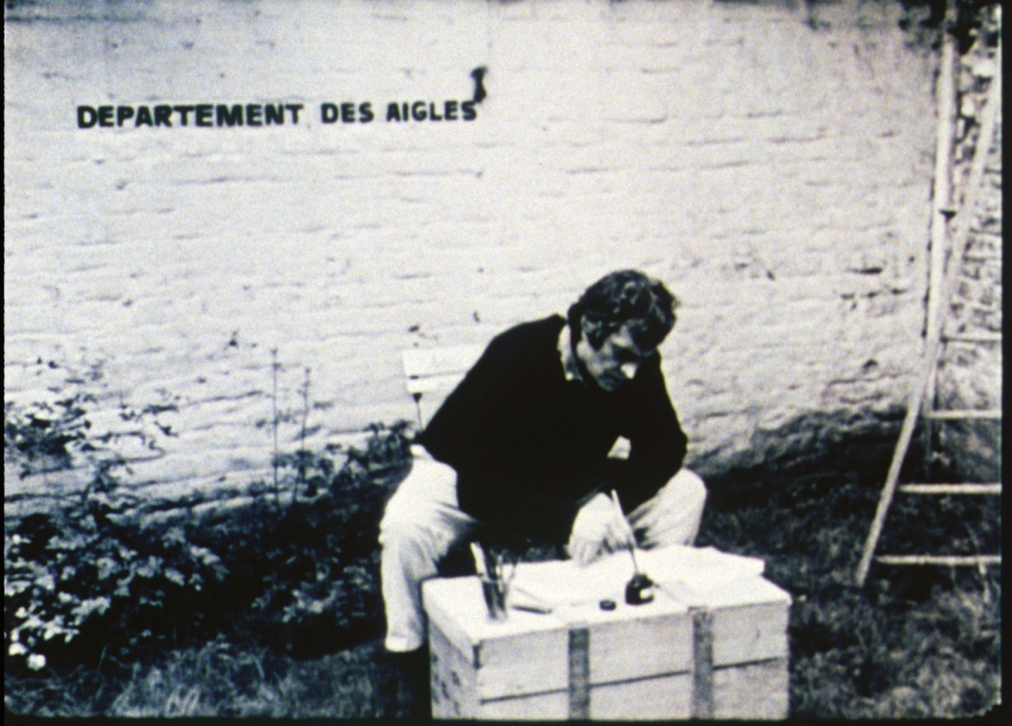
Figure 1. Marcel Broodthaers “La Pluie (a project pur une texte)” 1969
Figure 2. Alec Shepley, “Enactment #3”, 2014. Palika Park, New Delhi (Courtesy the artist).
Of ambivalence | To play | To level
Of anonymity | To ambit | To evaporate
Of purposeful purposelessness | To extend | To absorb
Of uncertainty | To stretch | To let go
To act | To sweep | To survey
To become lost | To stroll | To undo
To blow | To feel | To stumble
To breathe | To proceed | To wait
To bundle | To touch | To tell
To change direction | Of peregrination | To engage
To contour | Of dust | To relate
To crumble | Of refusal | To form
To drift | To join | To score
To encounter | To scope | To exhale
To escape | Of difference | To depart
To gather | To see | To shape
To heap | To delineate | To unearth
To lick | To range | To unfold
To lose | To tour | To unravel
To meander | To meet | To graze
To merge | To traipse | To encompass
To pile | To listen | To uncover
To prompt | To figure | To hang
To scribe | To rove | To unwrap
To trail | To talk | To unblock
To unstructure | Of restraint | To calibrate
To wander | To tread | To scrape

Figure 3. Alec Shepley, 2015 " Verb List” (after Richard Serra 1967).

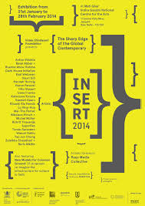
Figure 4. Raqs Media Collective “Insert2014” poster, 2014.
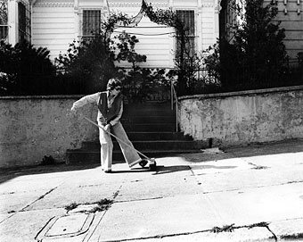
Figure 5. Jo Hanson, "Art That's Sweeping the City", Sweeping (for the camera) by her front steps, San Francisco, CA, 1980. (Source: http://greenmuseum.org/).

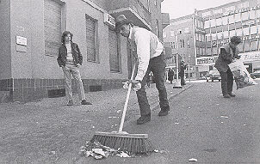
Figure 6. Joseph Beuys, “Ausfegen” (Sweeping) Aktion am 1. Mai 1972 auf dem Karl-Marx-Platz in Berlin, 1972. (Source: http://www.galerie-cyprian-brenner.de/).

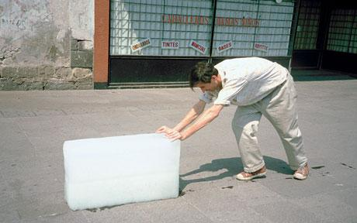
Figure 7. Francis Alÿs, “Paradox of Practice 1 (Sometimes Making Something Leads to Nothing)” Mexico City, 1997. (Source: http://www.francisalys.com/public/).

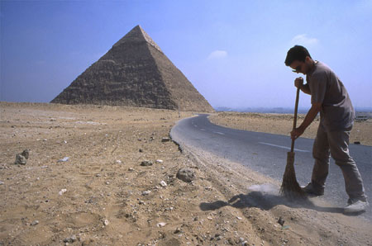
Figure 8. Regis Perray, “Sweeping the Western Road”, Giza, Egypt, March 1999. (Courtesy the artist, collection FRAC Franche-Comte, Besancon).

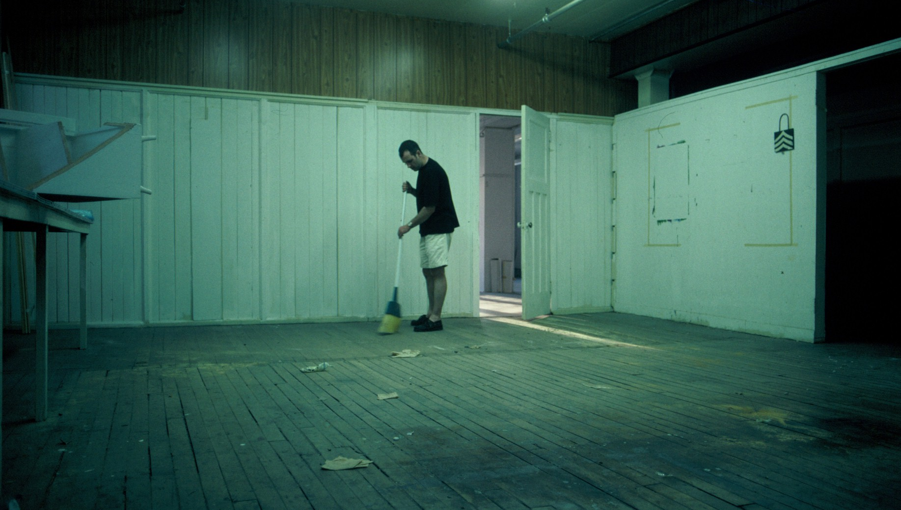
Figure 9. Alec Shepley, Untitled (Sweeping Albert Street Studio). Winnipeg Artspace, Winnipeg Fringe Festival, 1999. (Image copyright Alec Shepley)

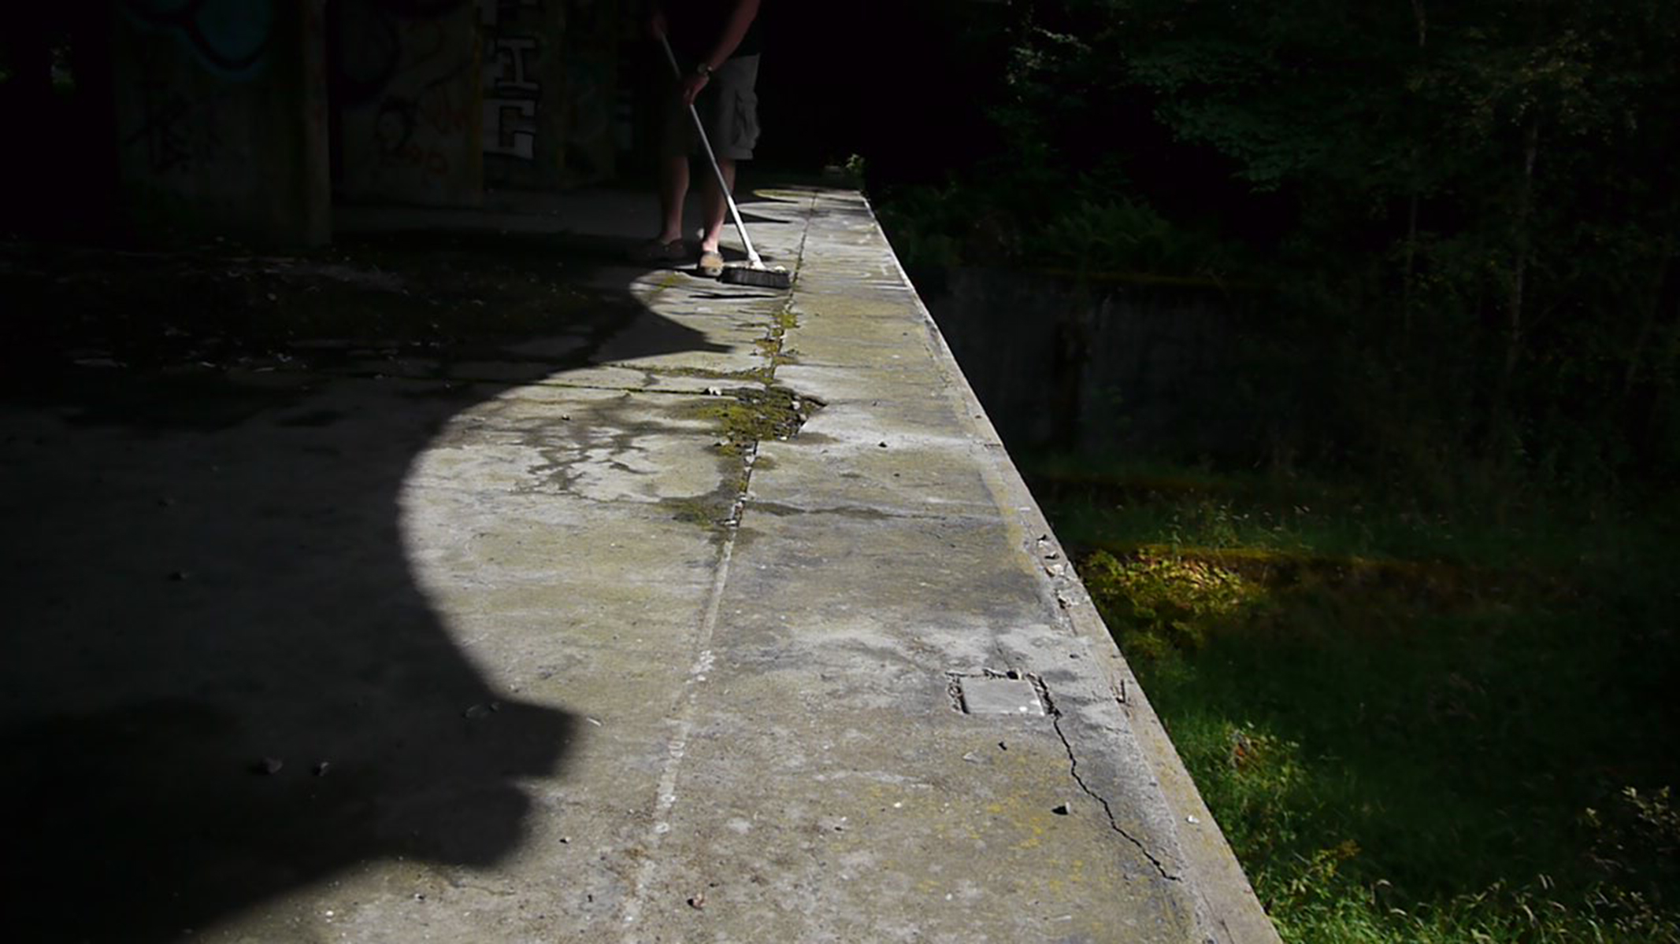
Figure 10. Alec Shepley, tracing the line of a shadow (Still from “I am from Leonia”), 2015. Kilmahew, Scotland. (Courtesy the artist).

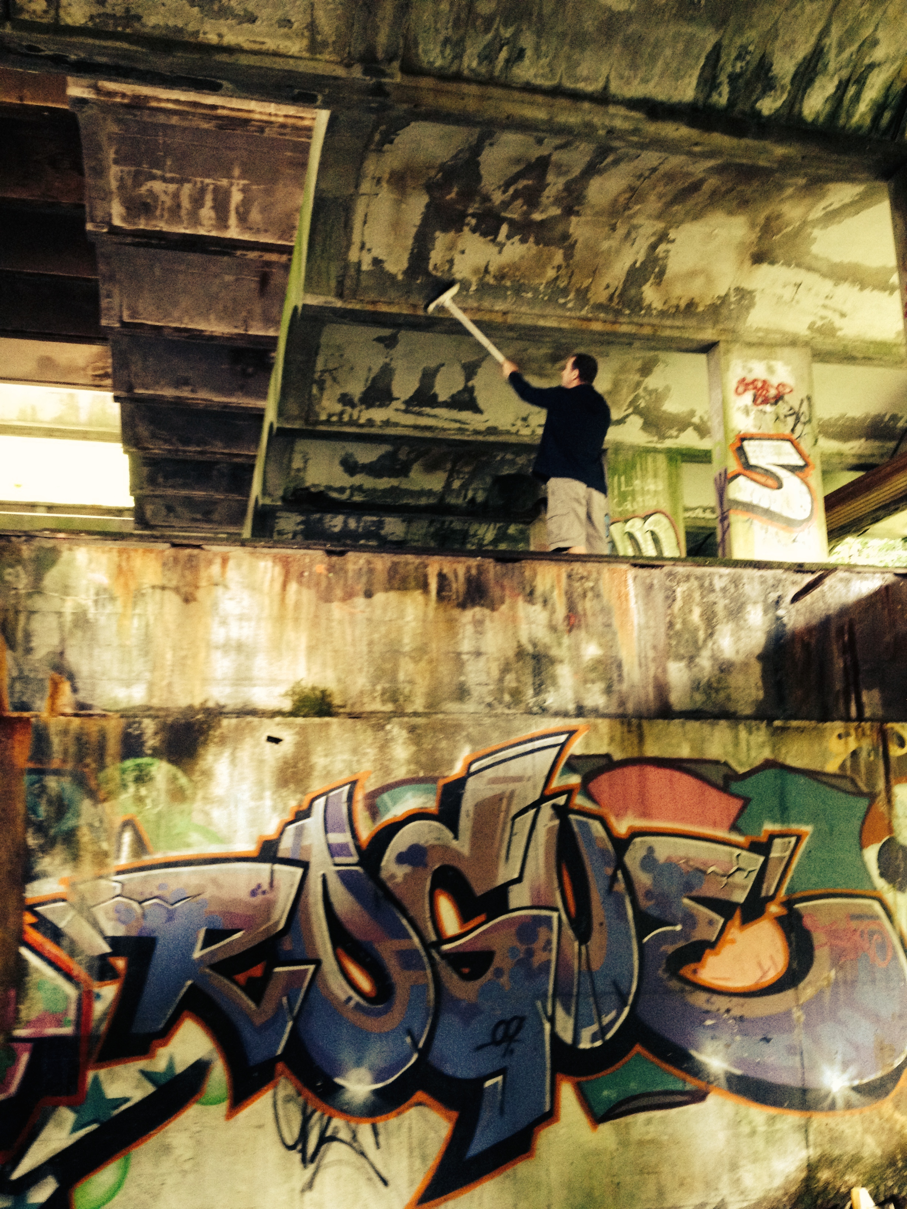
Figure 11. Alec Shepley, Untitled (Sweeping St Peters Seminary) 2014. Kilmahew, Scotland. (Courtesy the artist).

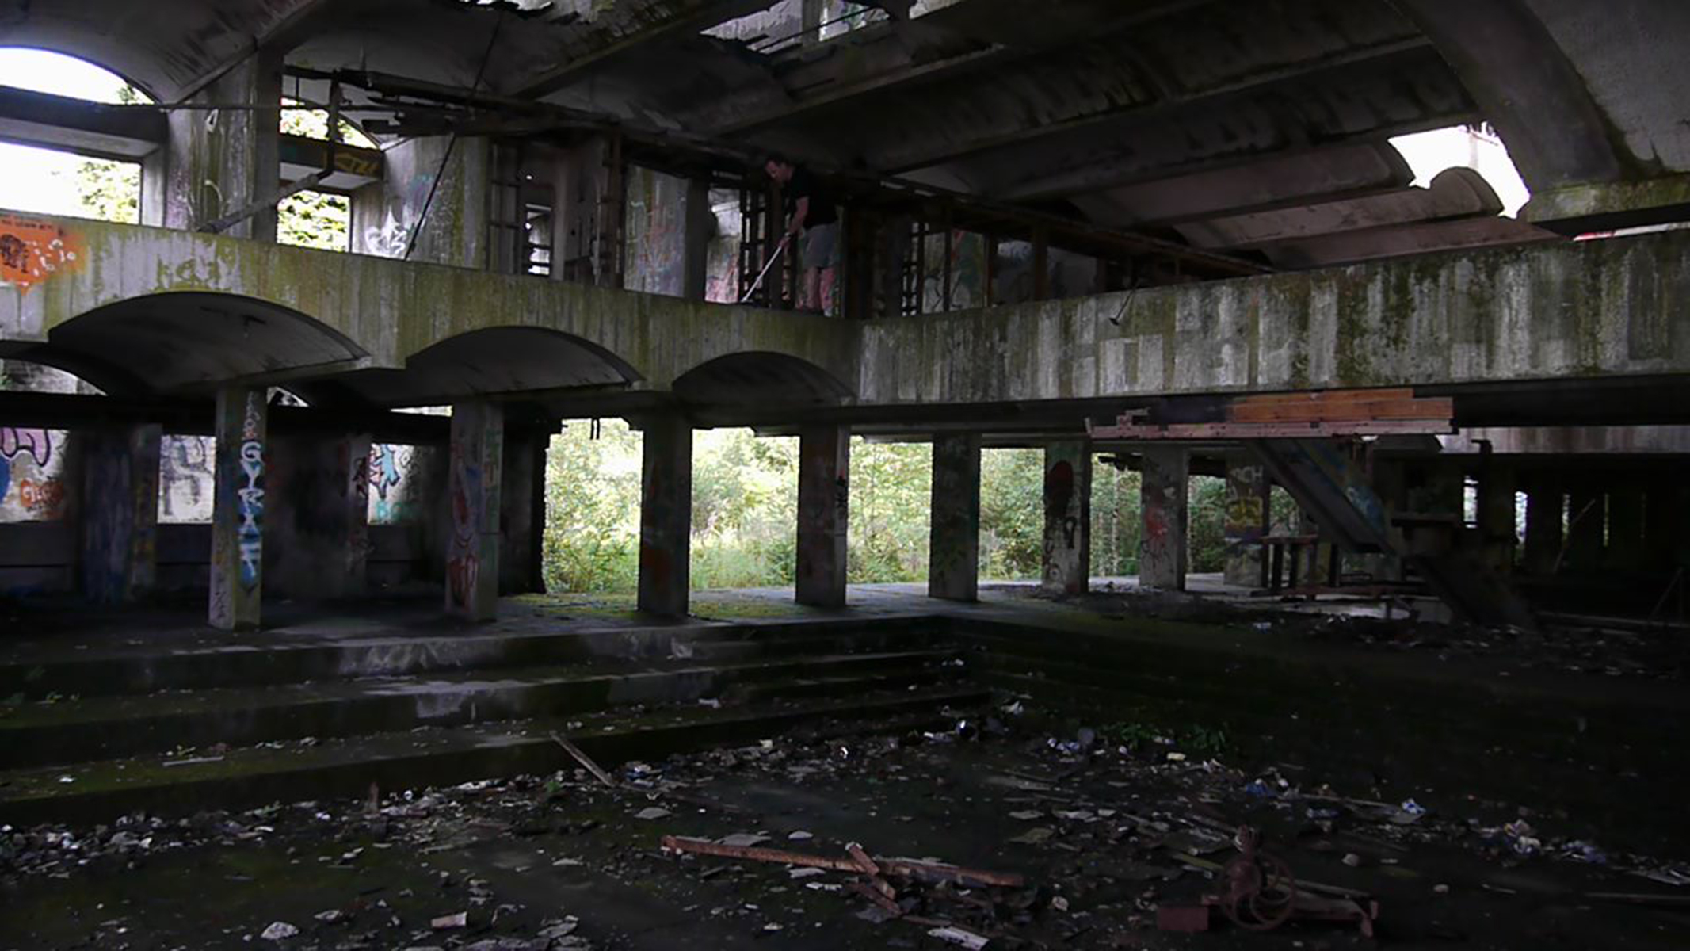
Figure 12. Alec Shepley, tracing a contour (Still from “I am from Leonia”), 2015. Kilmahew, Scotland. (Courtesy the artist).

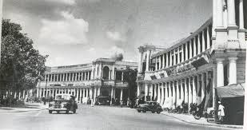

Figure 13. Connaught Place, New Delhi c.1950’s

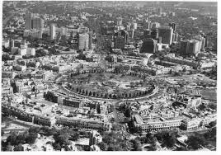
Figure 14. Connaught Place, New Delhi now.

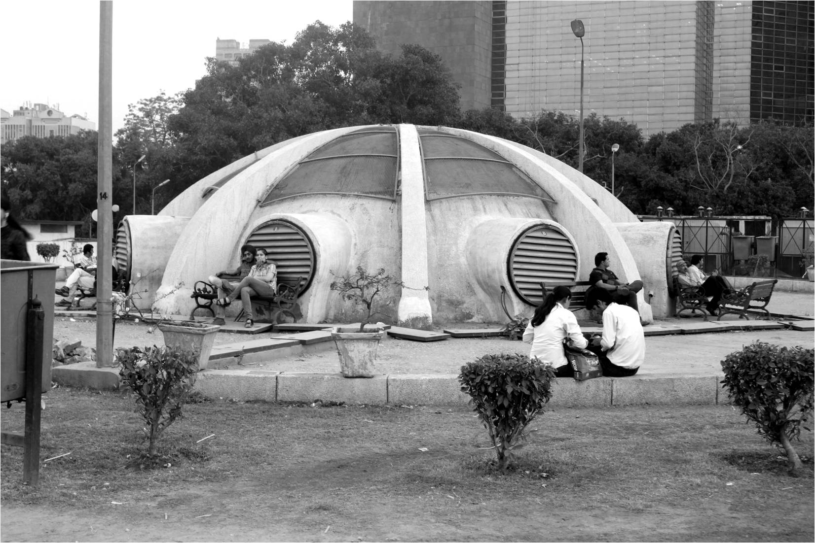
Figure 15. Palika Park, New Delhi (Image courtesy of Raqs Media Collective, INSERT2014)

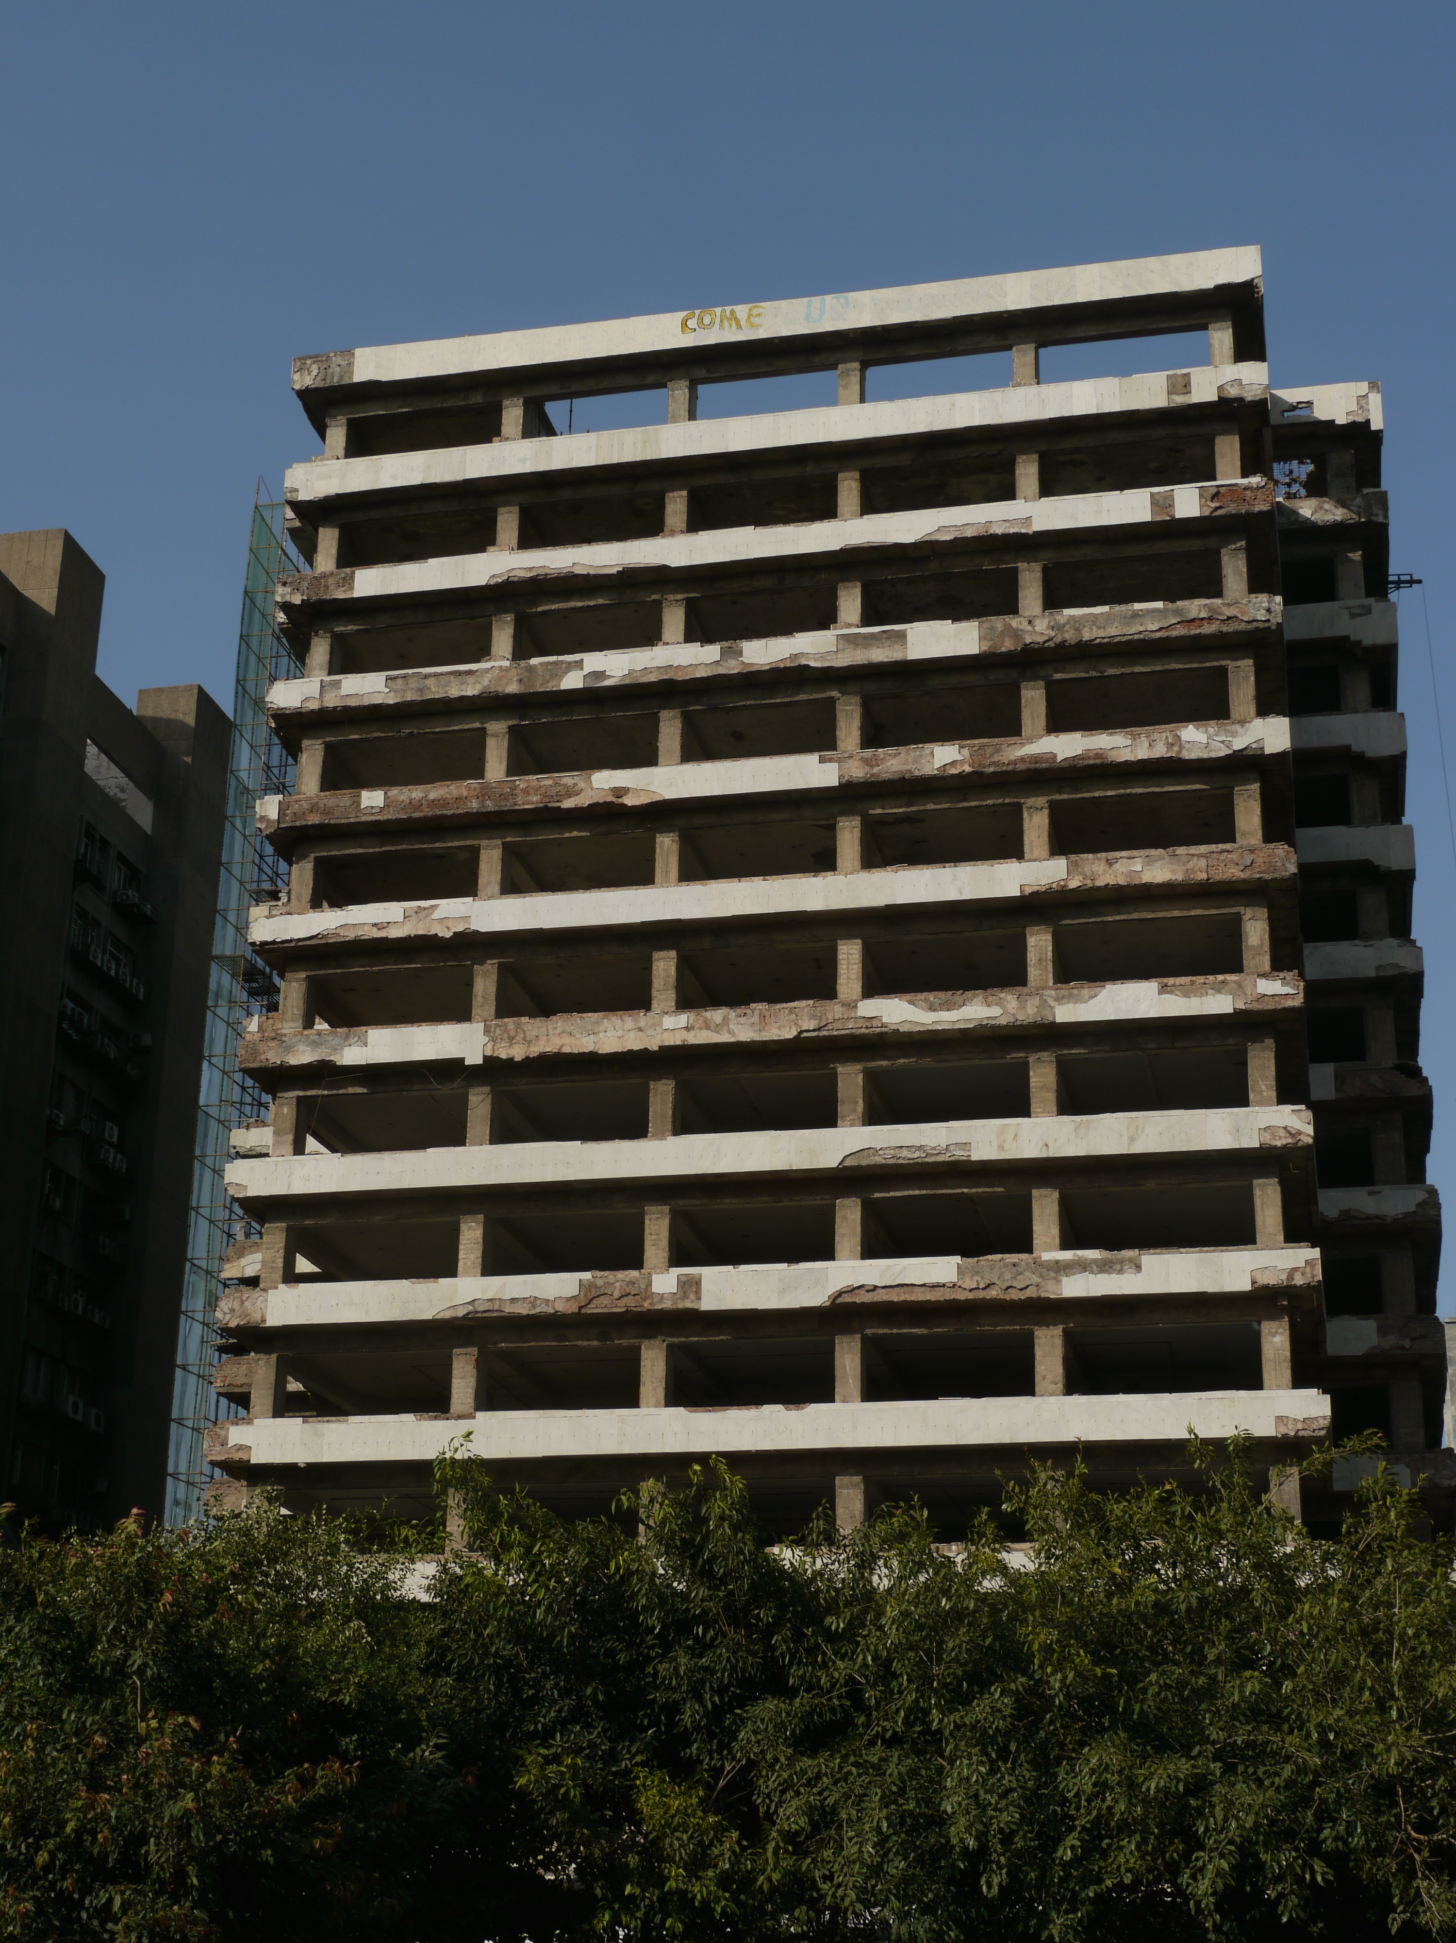
Figure 16. Skipper Tower, 2014. New Delhi (Courtesy the artist)

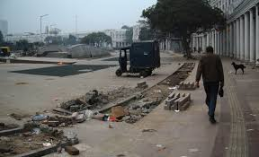
Figure 17. Connaught Place, New Delhi 2011 (commons.wikimedia.com)

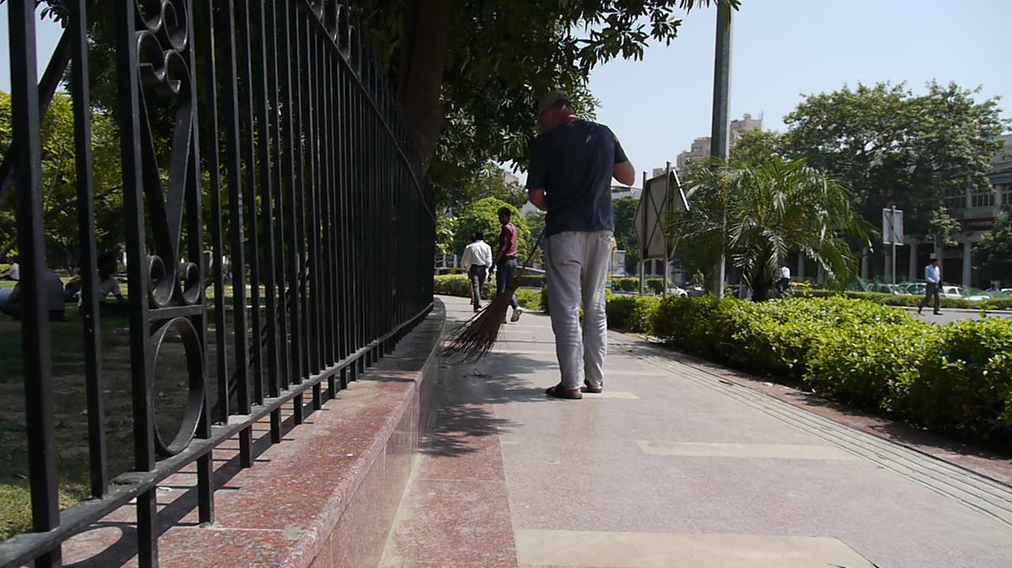
Figure 18. Alec Shepley, “Enactment #1” 2014. Connaught Place, New Delhi (Courtesy the artist).

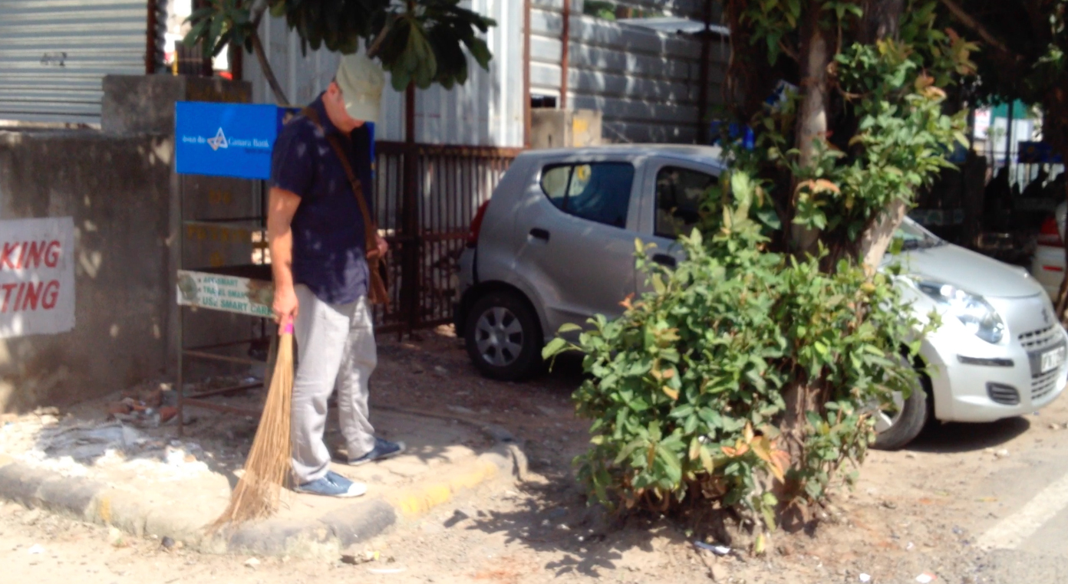
Figure 19. Alec Shepley, “Enactment #2”, 2014. Skipper Tower, New Delhi (Courtesy the artist).

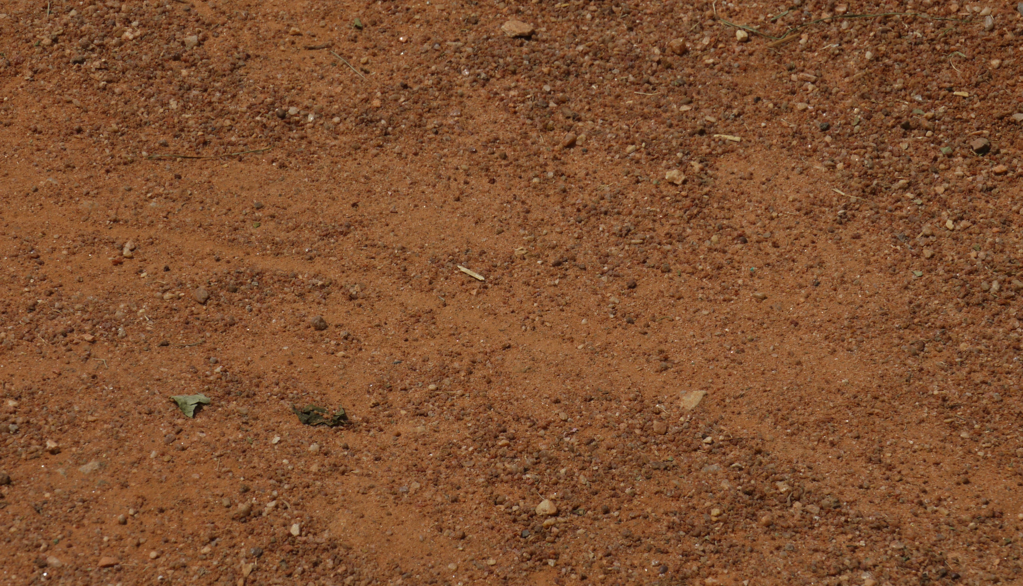
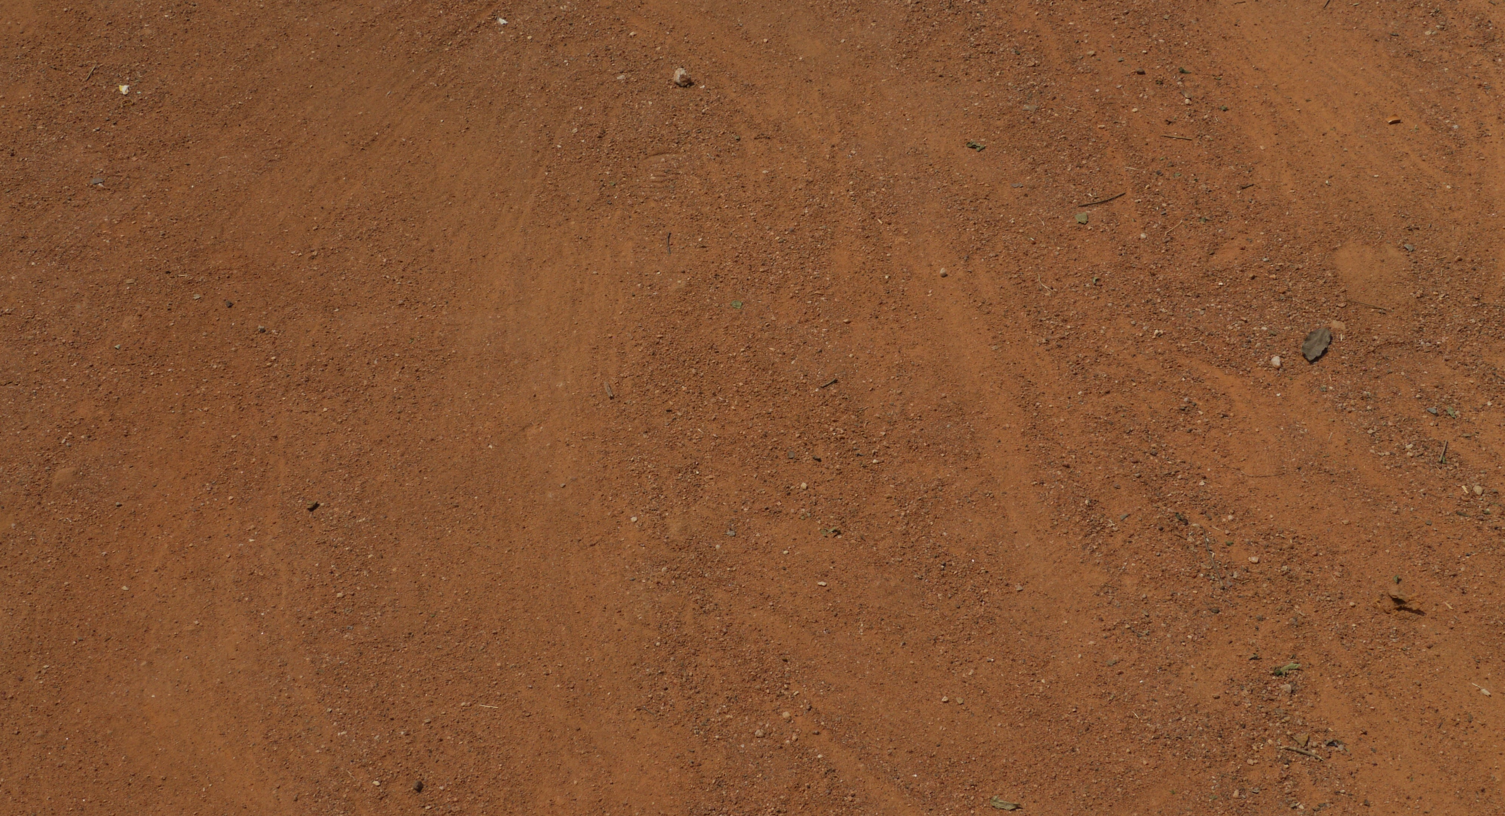
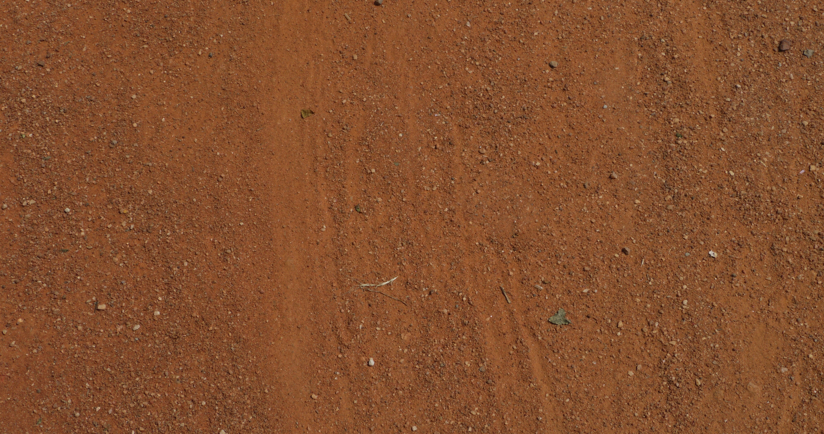
Figures 20, 21 & 22. Alec Shepley, Untitled (Temporary dust drawings made during impromptu sweeping enactment) 2014. India Gate, New Delhi (Courtesy the artist).

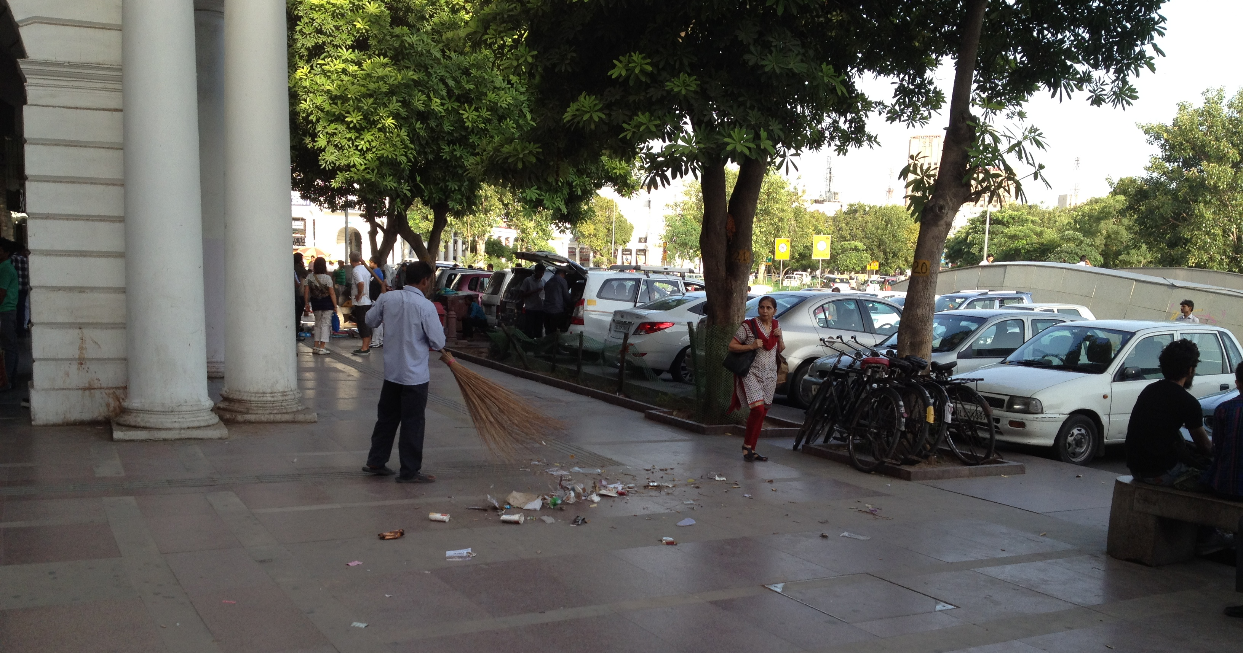
Figure 23. Street cleaner, 2014. Connaught Place, New Delhi (Courtesy the artist).

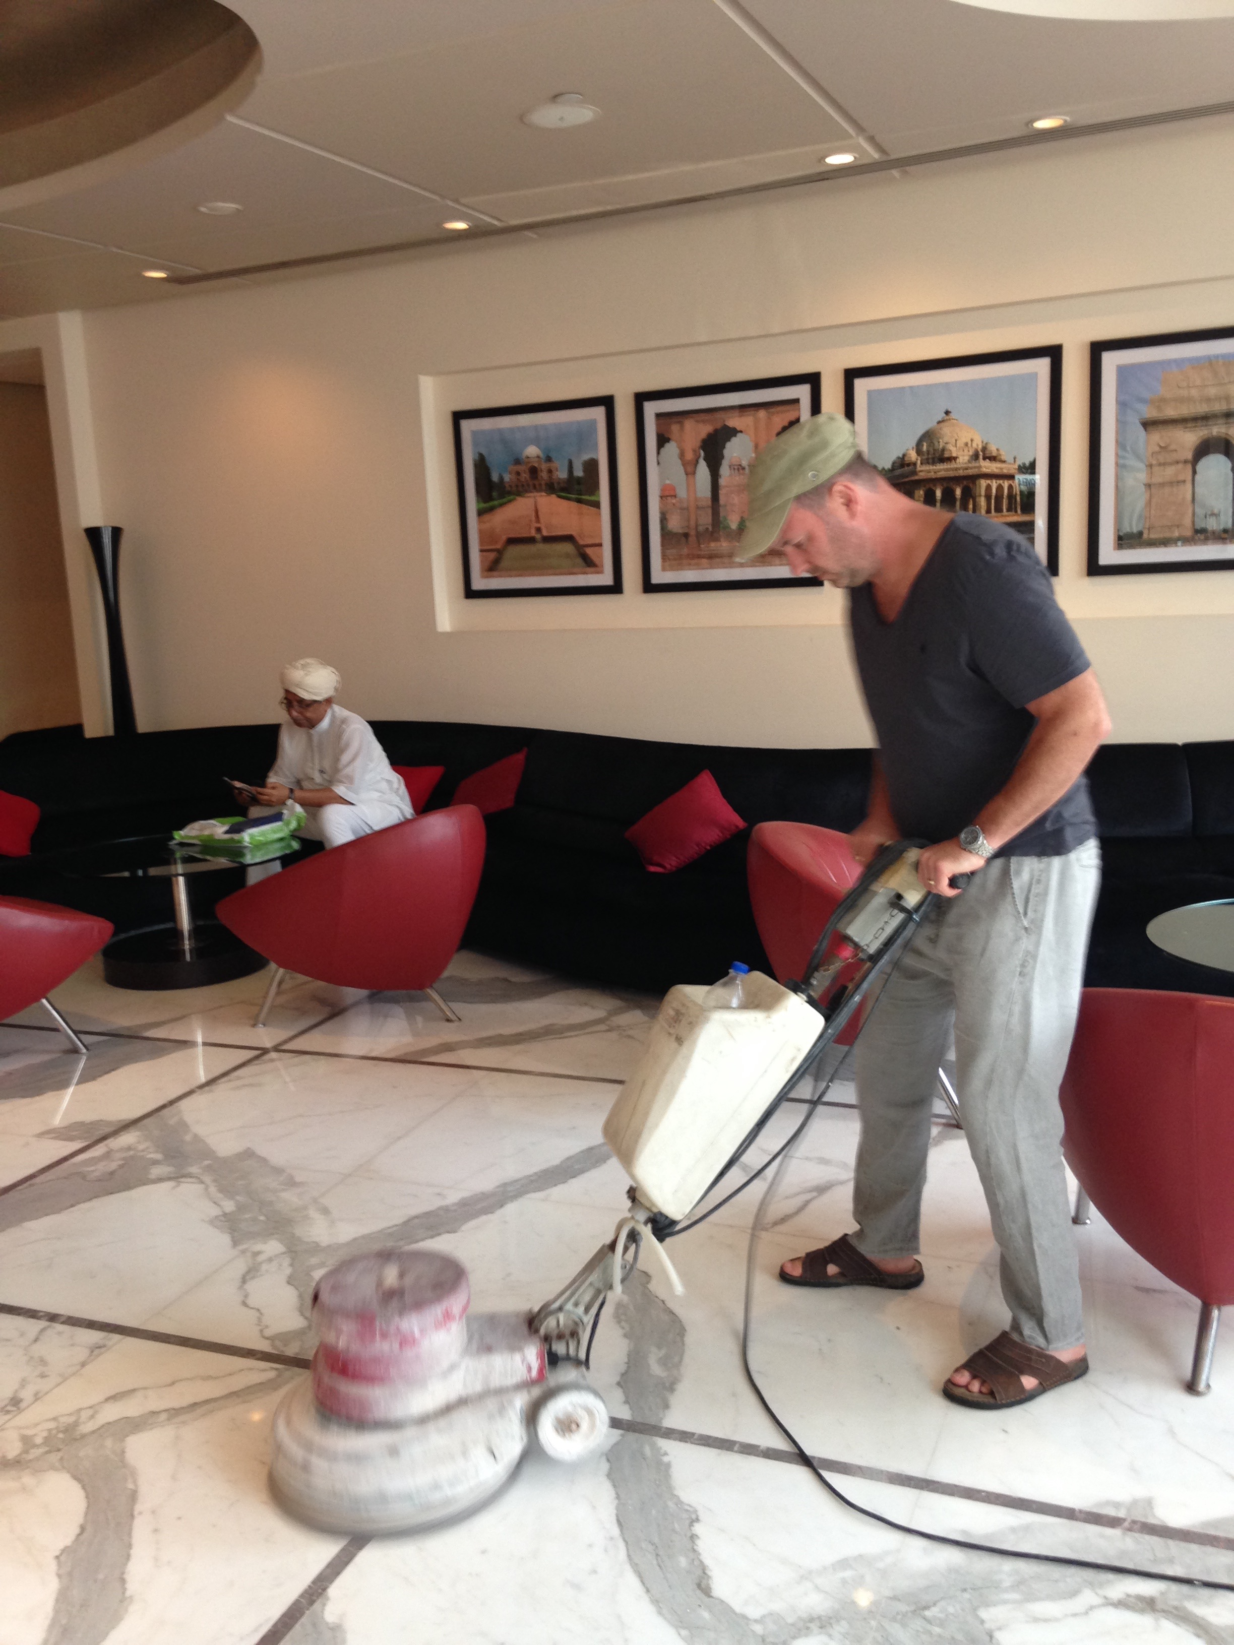
Figure 24. Alec Shepley, Untitled (Floor buffing enactment) 2014. Radisson, New Delhi (Courtesy the artist).

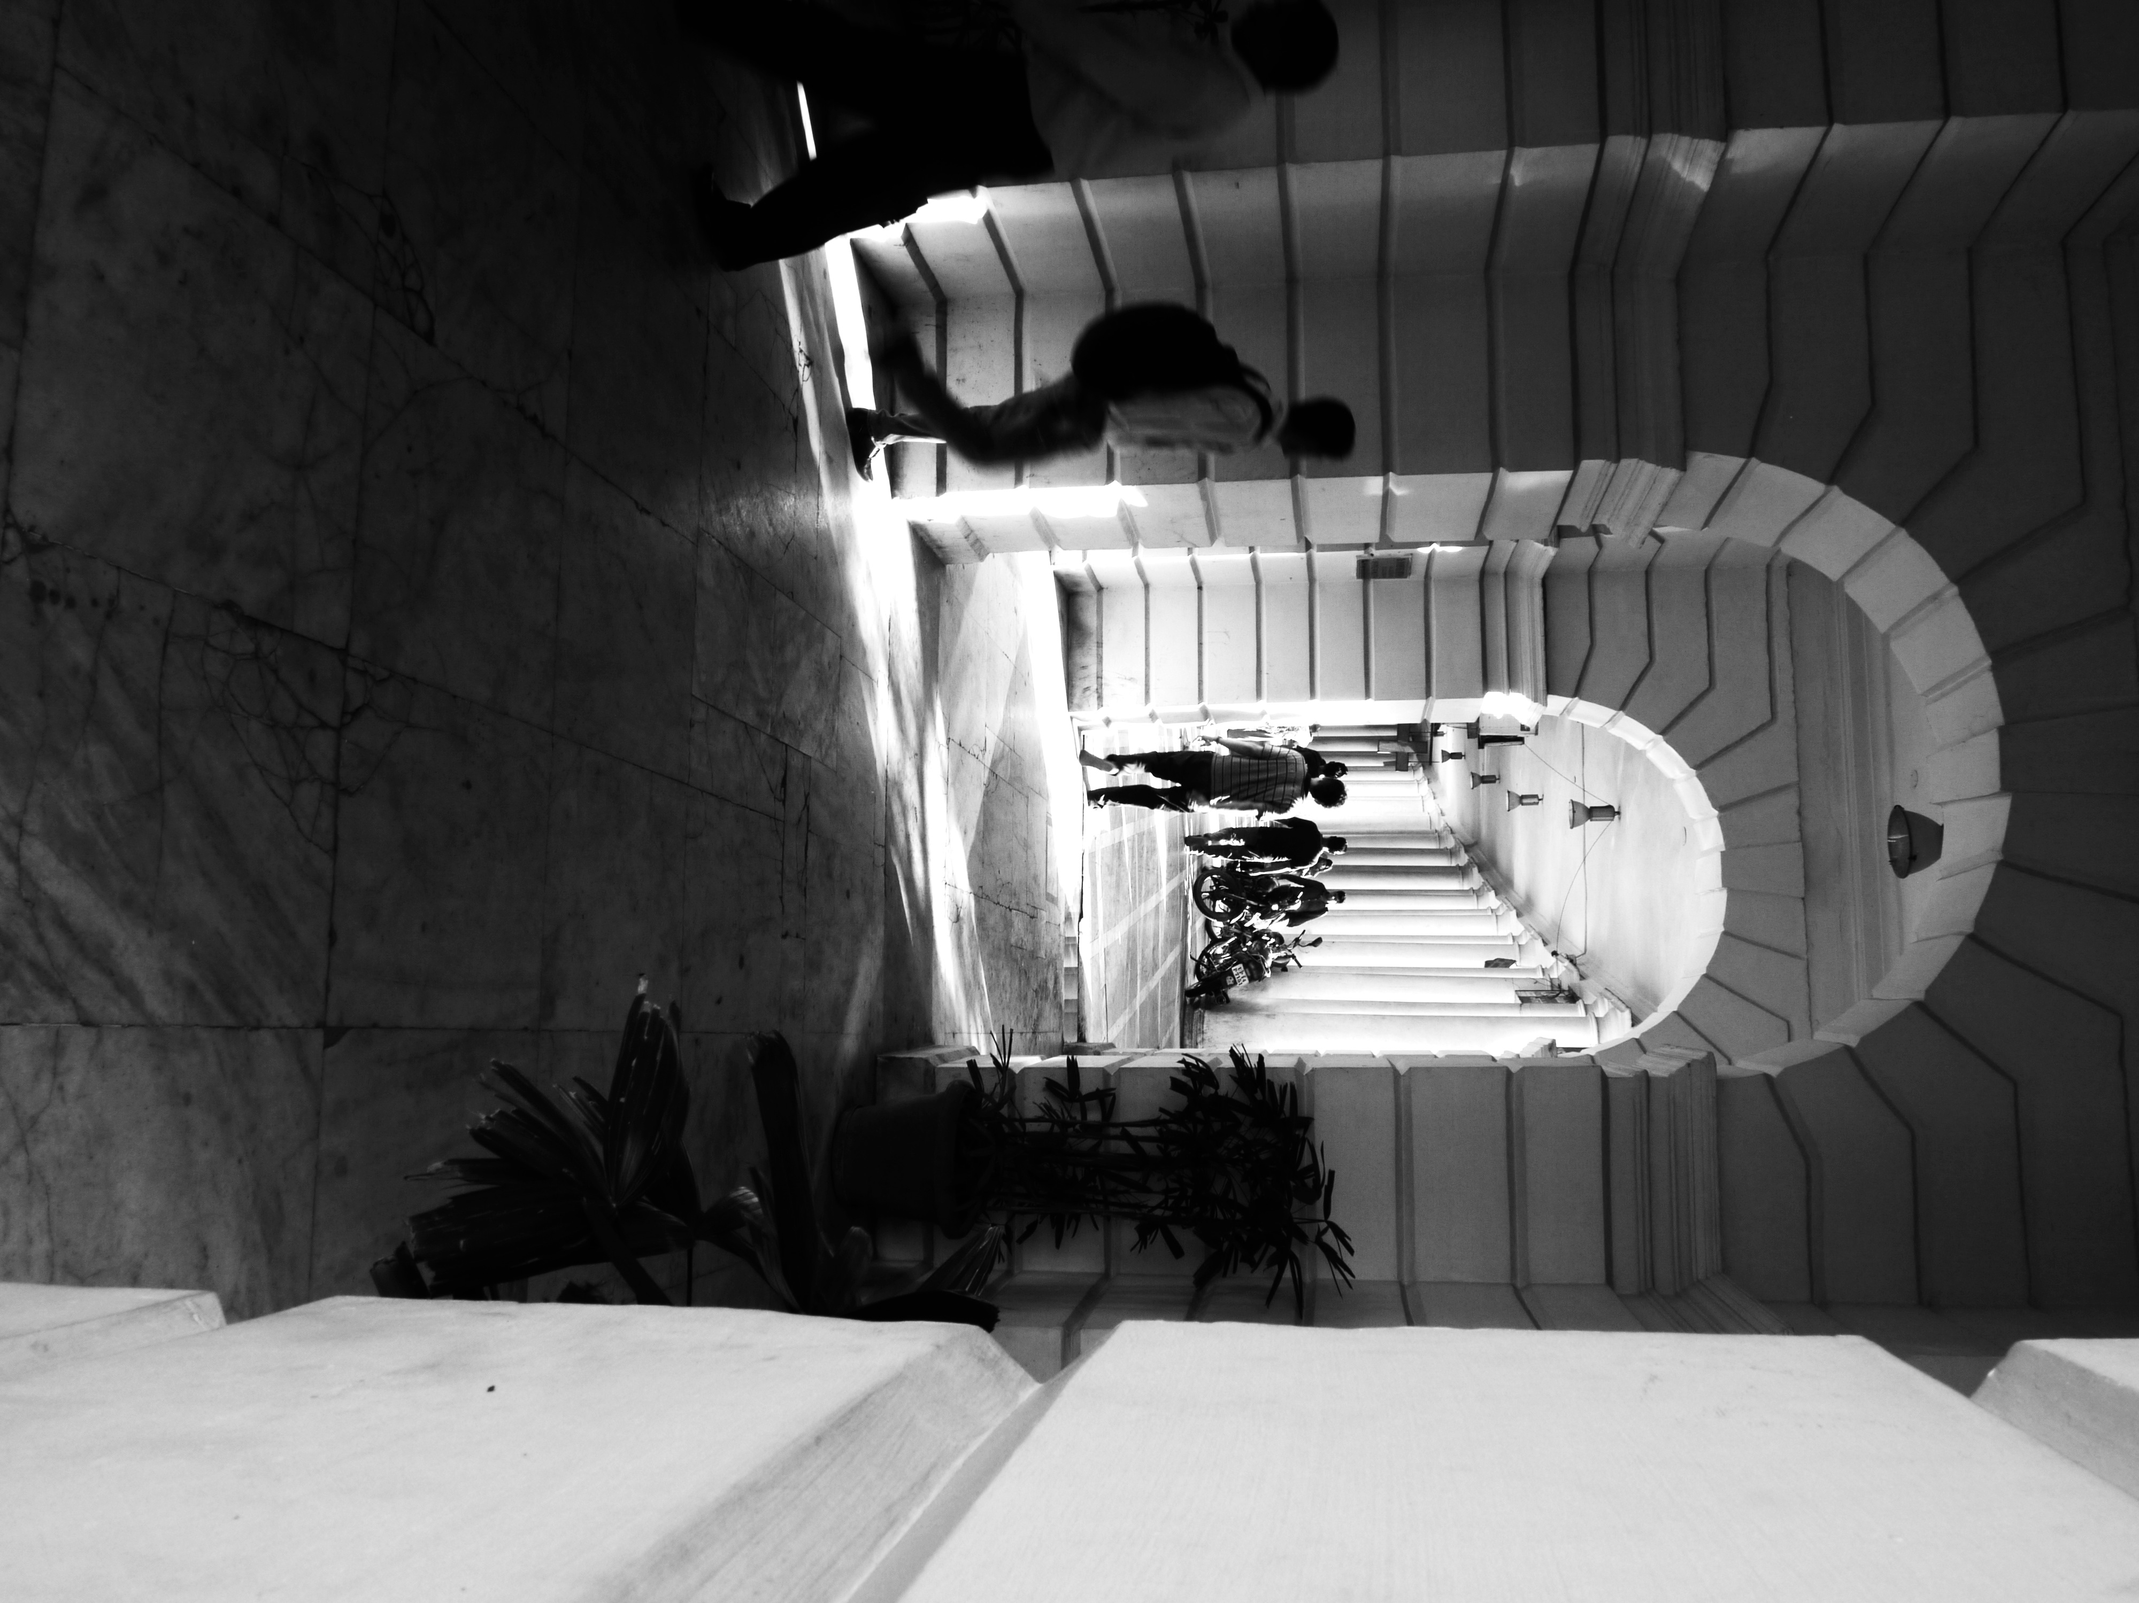
Figure 25. Alec Shepley Untitled (drawing #1) 2014, Connaught Place, Delhi (Courtesy the artist).

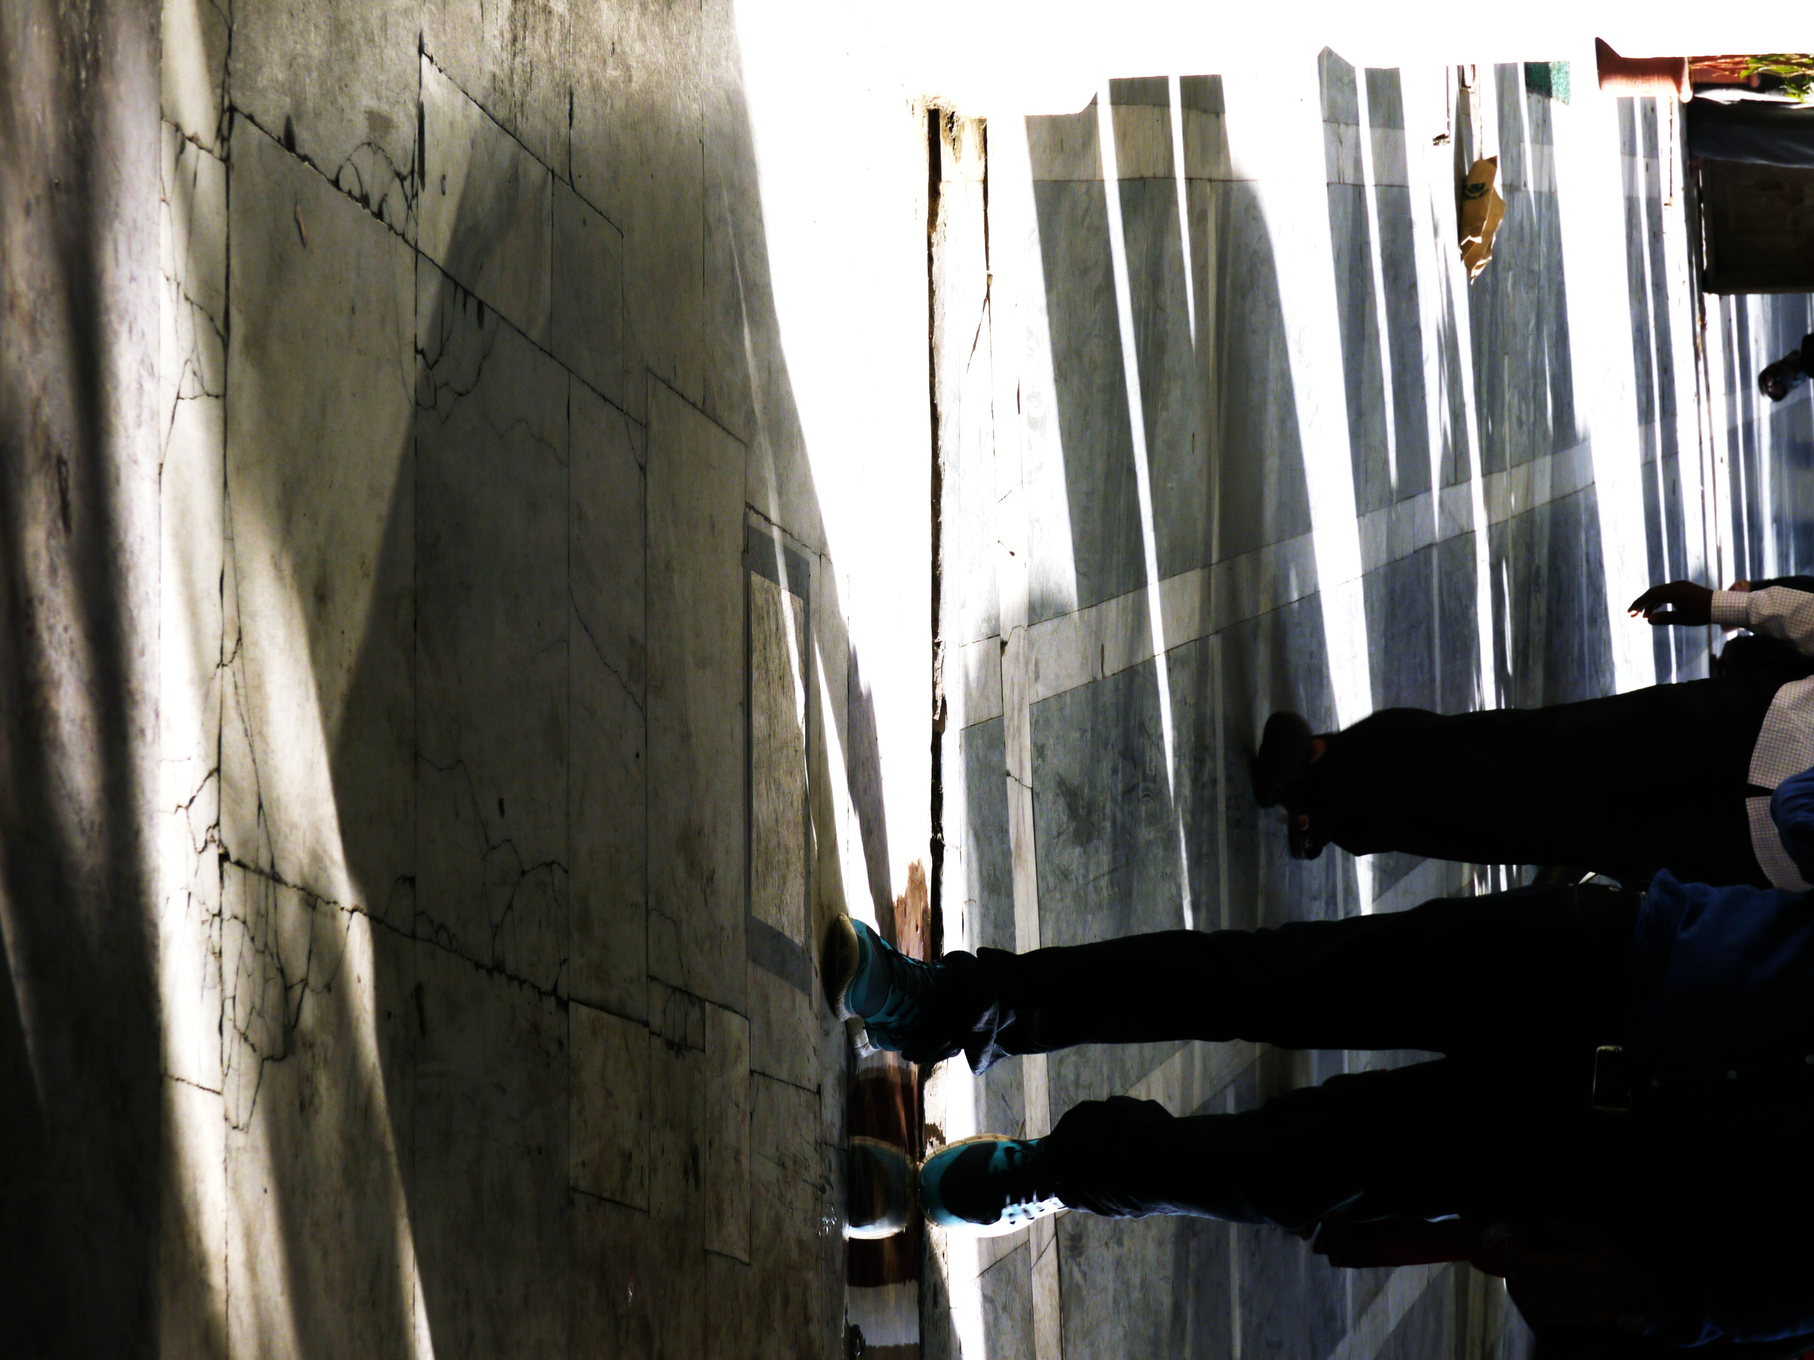
Figure 26. Alec Shepley Untitled (drawing #1) 2014, Connaught Place, Delhi (Courtesy the artist).

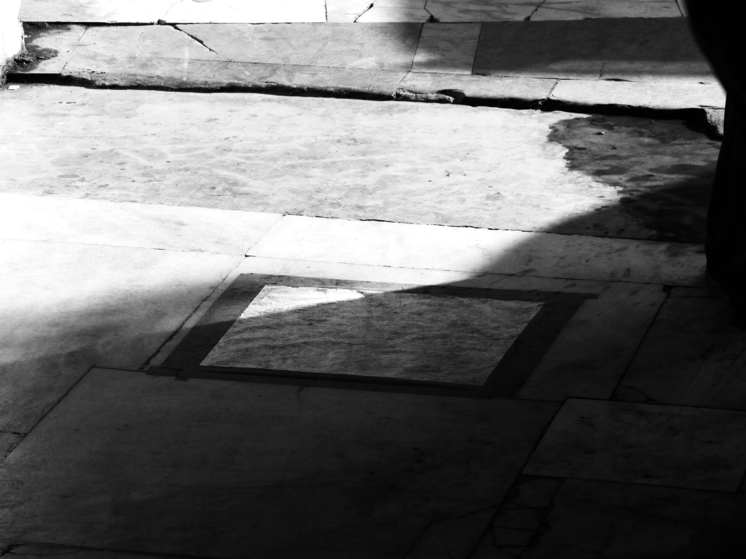
Figure 27. Alec Shepley Untitled (drawing #1) 2014, Connaught Place, Delhi (Courtesy the artist).

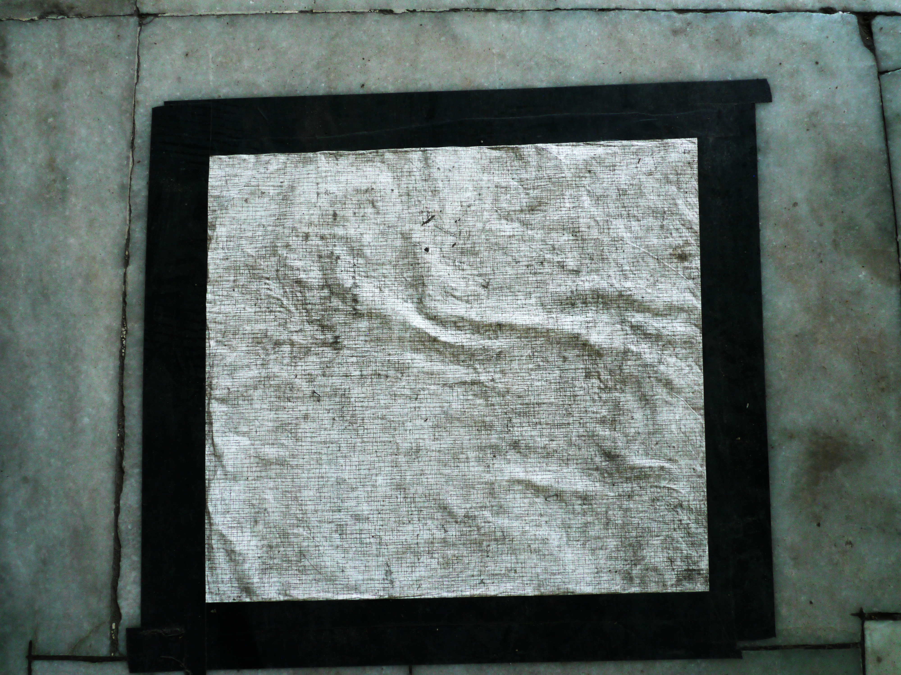
Figure 28. Alec Shepley Untitled (drawing #1) 2014, Connaught Place, Delhi (Courtesy the artist).

- Substance/essence
- Quantity/how much
- Qualification/quality
- Relative/relation
- Where/place
- When/time
- Being in position/attitude
- Having a state/condition
- Doing/action
- Being affected/affection

Figure 29. Aristotle’s 10 categories of objects of human apprehension
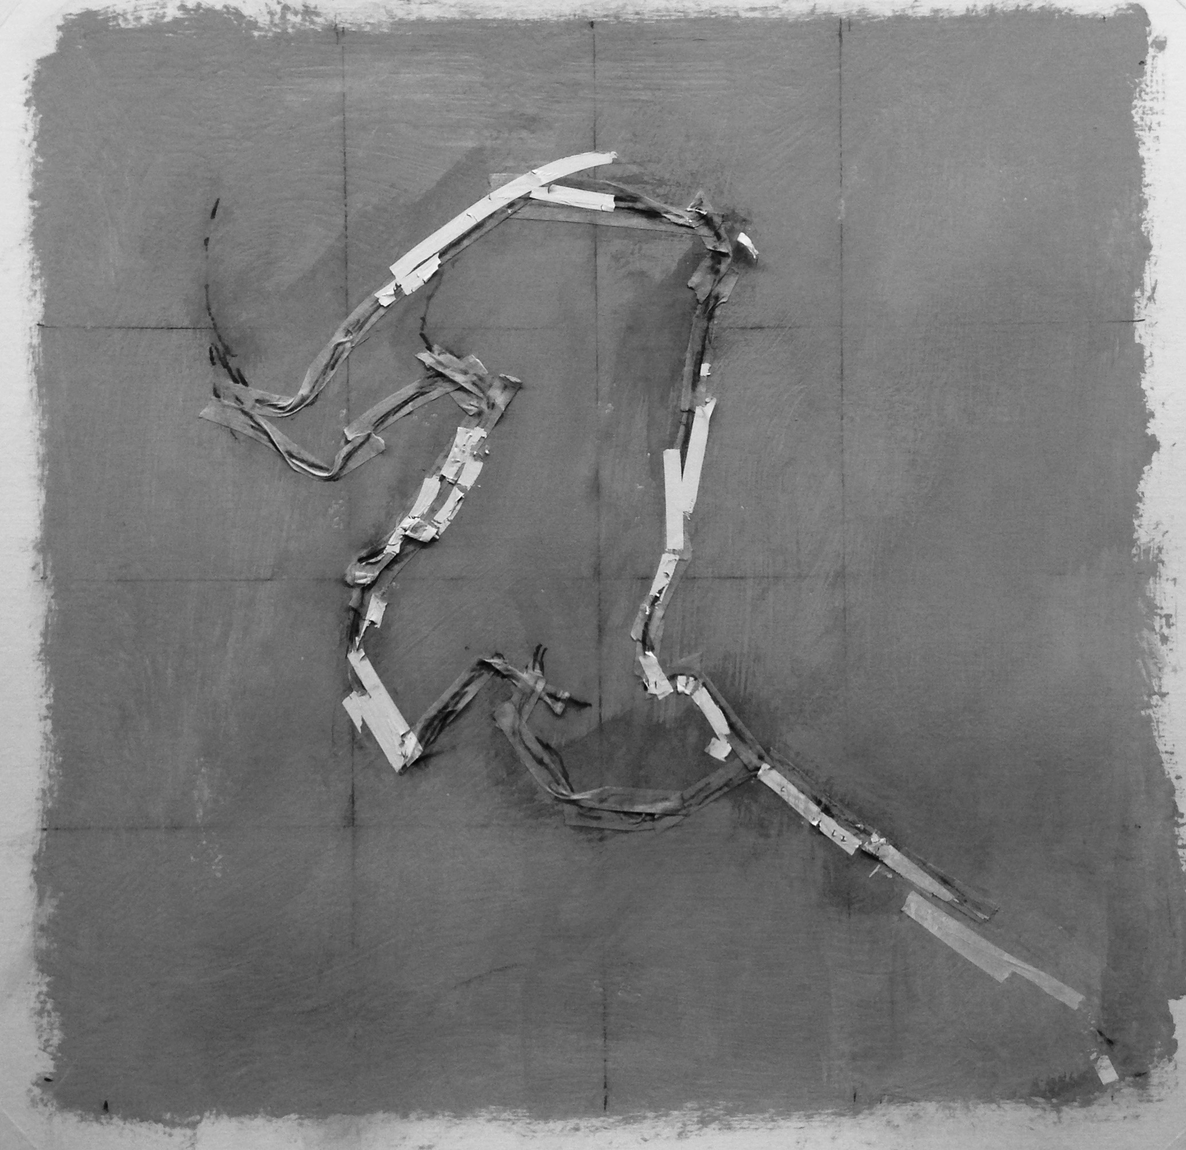

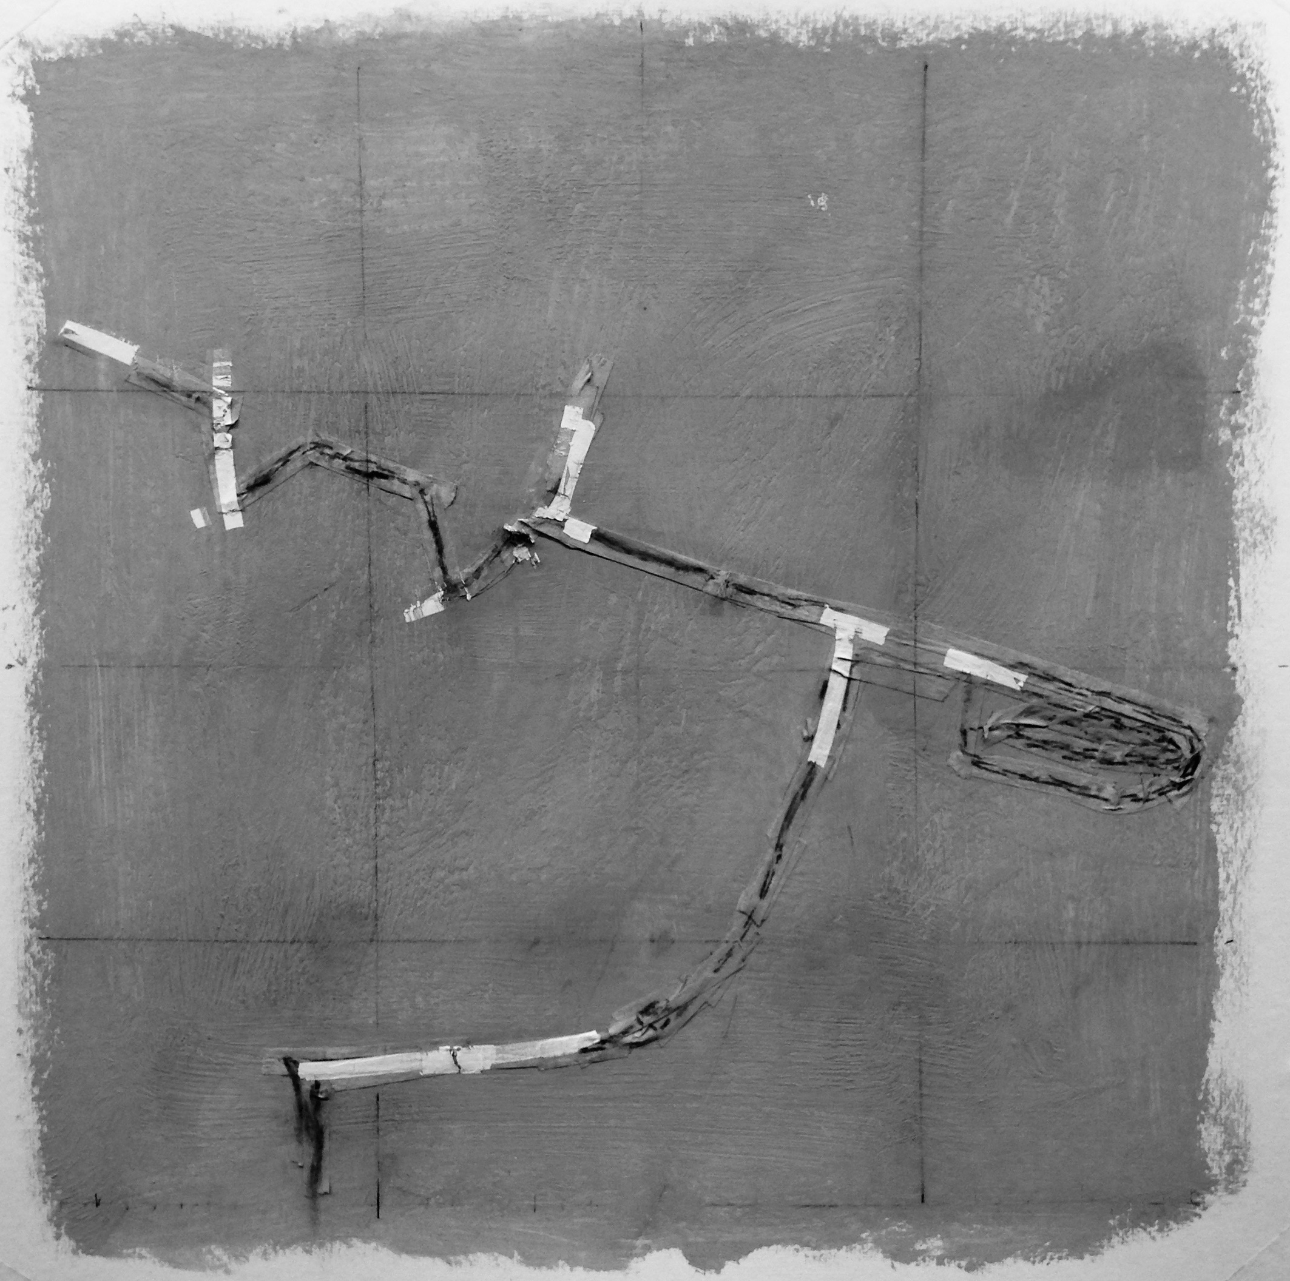
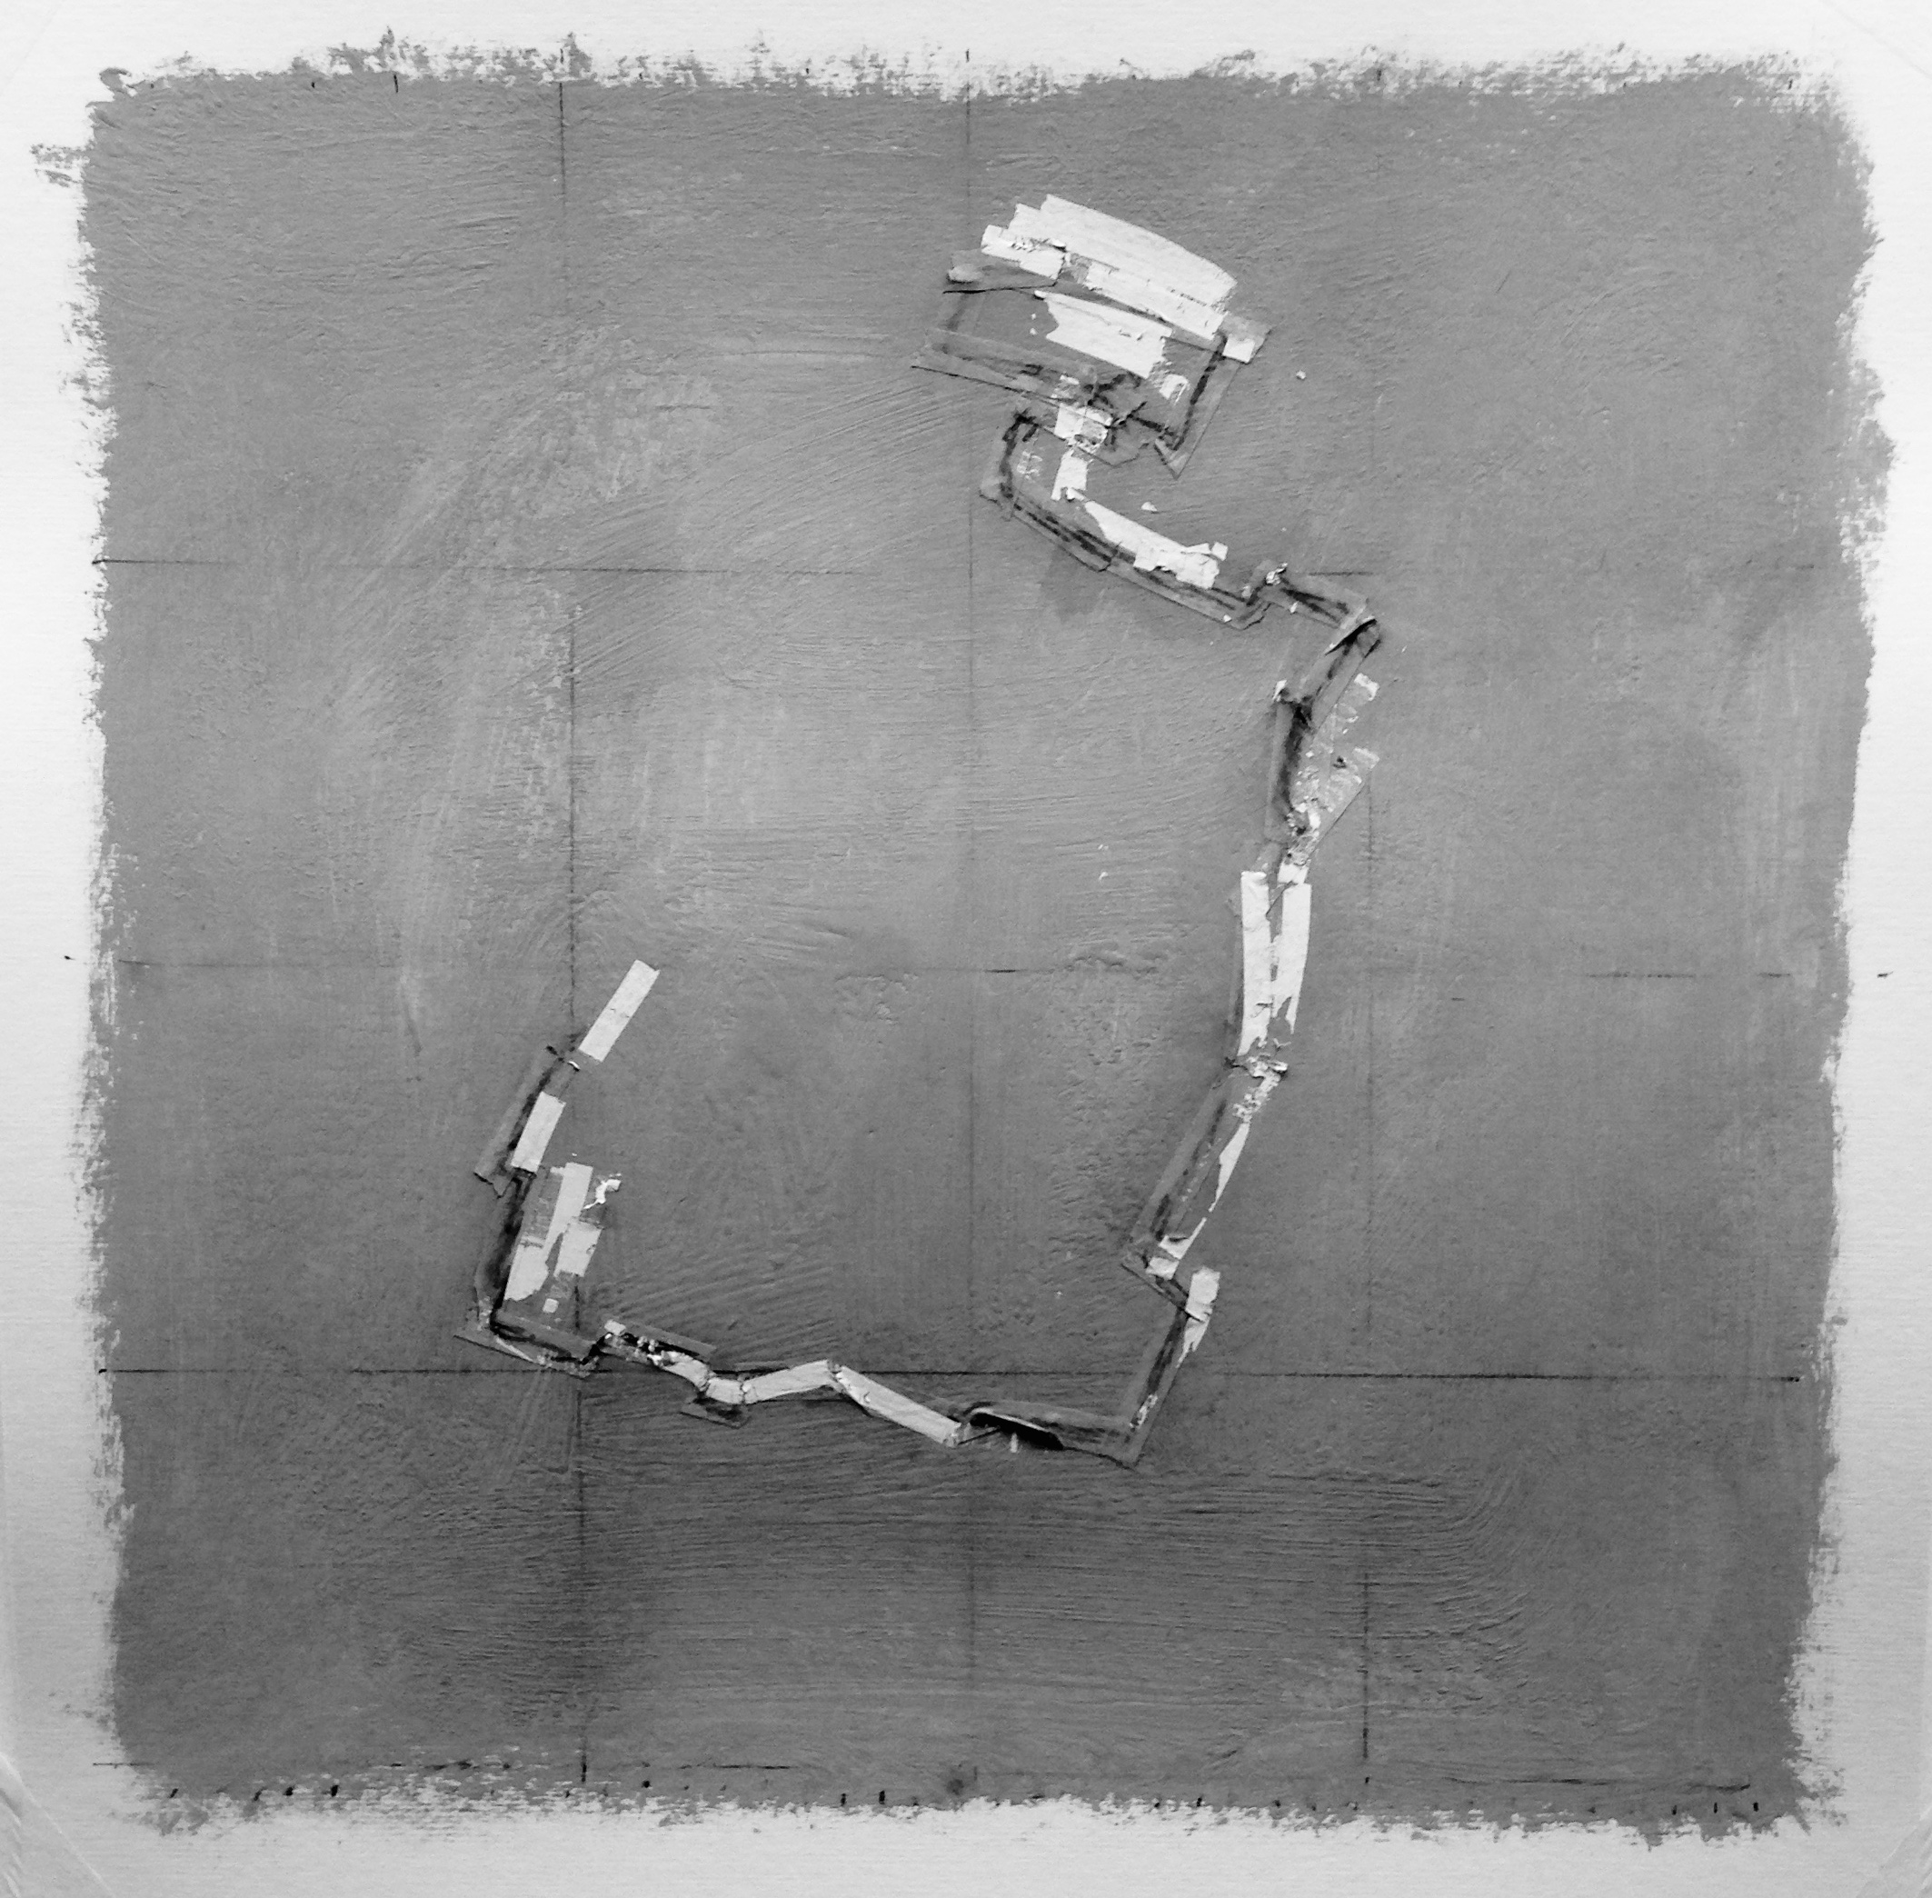

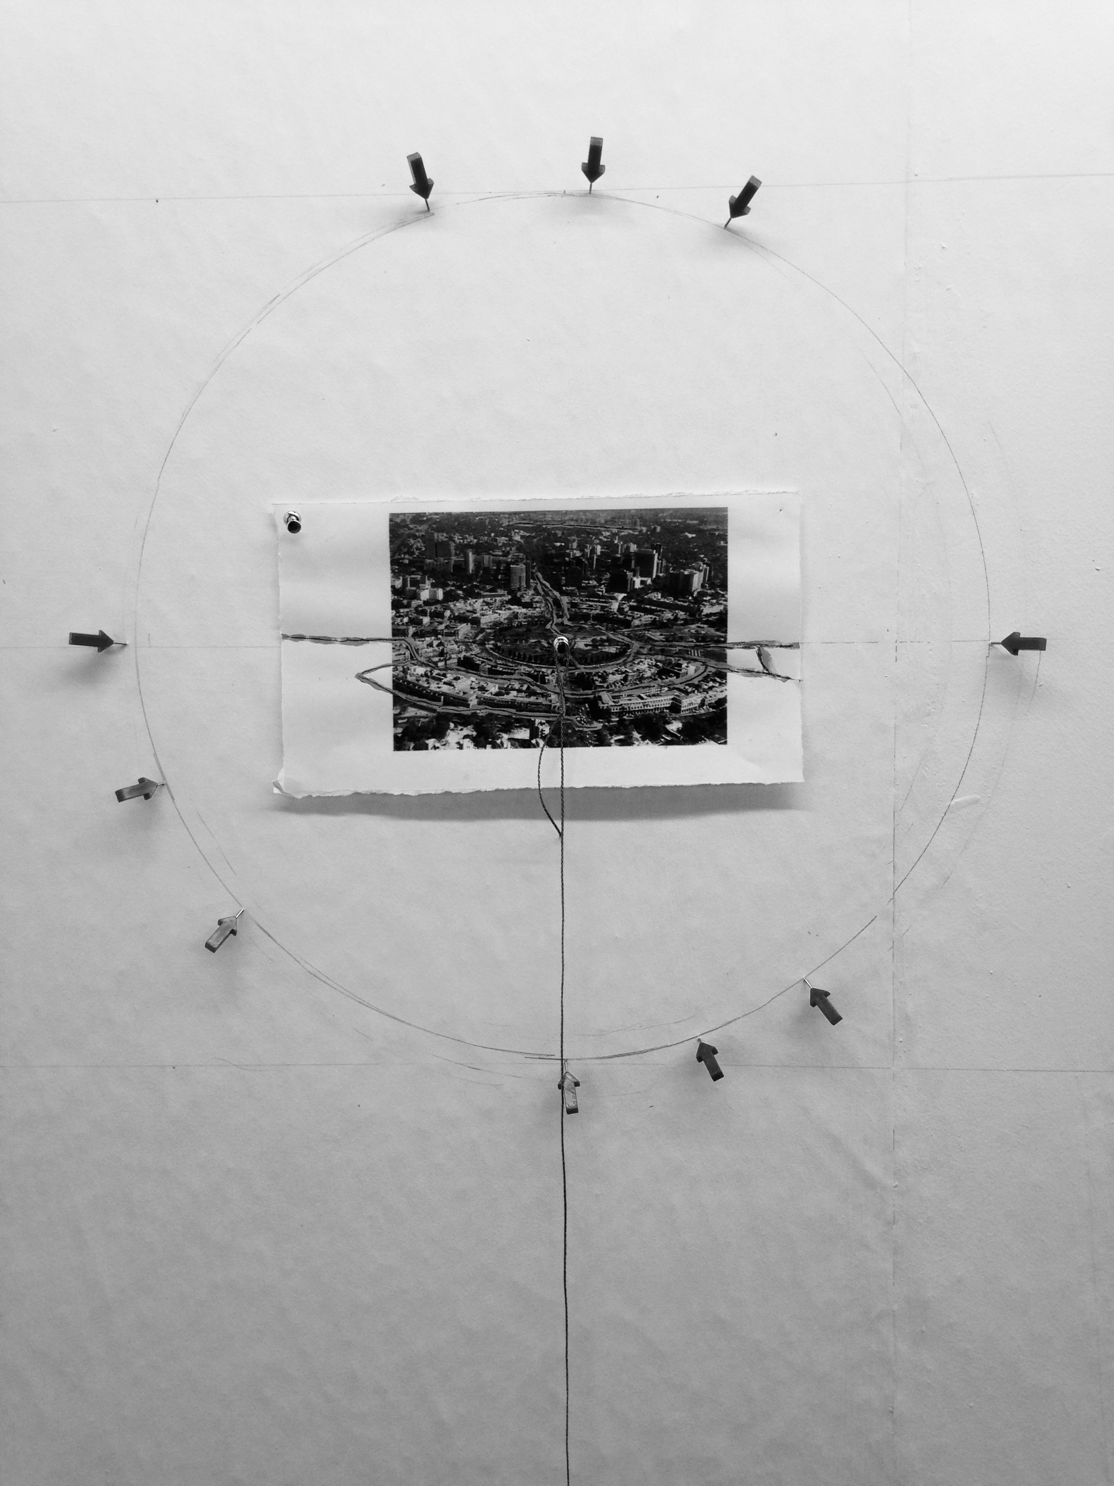
Figure 30. Alec Shepley DelhiDRiFT (drawings) 2015/16 Connaught Place, Delhi (Courtesy the artist).

References

Ali, M. 2014. “Artist as Initiator”, in Time Out Delhi, Around Town January 17, 2014 11.48am, from http://www.timeoutdelhi.net/around-town/features/artist-initiator, accessed 11:51 22nd May, 2014)

Bagchi, J., Narula, M., Sengupta, S. in Sarda, S. (Ed.) 2014. INSERT2014, 10. INLAKS Shivdasani Foundation, Goethe Institute, New Delhi, India Foundation for the Arts, Bangalore.

Benjamin, W. 1927-1940. The Arcades Project, in Tiedemann, R, (Ed.) 2002, 12.
Belknap Press, Cambridge, Mass. Translation by Eilan, H. and McLaughlin, K.

Buchloh, Benjamin, HD. 1997. “Conceptual Art, 1962-1969: From the Aesthetic of Administration to the Critique of Institutions.” In Krauss, R., Michelson, A., Bois, Y-A., Buchloh, B. H. D., Foster, H., Hollier, D. and Kolbowski, S. (Eds.) 1997 October: The Second Decade, 1986-1996, 117-155. The MIT Press, Cambridge Mass.

Calvino, I. 1979. Invisible Cities, 91. Picador/Pan Books Ltd., London. Translated from Italian by William Weaver. Translation copyright Harcourt Brace Jovanovich, Inc. 1974.

De Certeau, M. 1984. The Practice of Everyday Life, 105. University of California Press, Berkeley. Translated from French by Stephen Rendall.

Duchamp, M. 1913. From the notes assembled in À l’infinitif (The White Box), reprinted in Duchamp du signe, ed. Michel Sanouillet and Elmer Peterson, 1975, 105. Flammarion, Paris.

Einstein, A & Infeld, L. 1938. The Evolution of Physics, 92. Simon & Schuster, New York.

Crow, Thomas E 1996. The Rise of the Sixties: American and European Art in the Era of Dissent, 177. London: George Weidenfeld and Nicolson.

Getzels, J. W. & Csikszentmihalyi, M. 1976. The Creative Vision: A Longitudinal Study of Problem Finding in Art, 174-178. John Wiley & Sons, New York.

Kosuth, J. 1977. Comments on the First and Second Frame in Guercio, G. 1991 Art after Philosophy and After: Collected Writings, 1969-90 169-173. MIT, Cambridge Mass.

Kunitz, D. 2011. “Texting: The Artist as Writer as Artist”, Modern Painters, Summer 2011 Issue, 47-52.

Kwon, M. 2000. One Place After Another: Notes on Site Specificity. In Suderberg, E. Ed.) 2000 Space, Site, Intervention: Situating Installation Art, 38-63. University of Minnesota Press, Minneapolis.

Matta-Clark, G. 1974. “Splitting the Humphrey Street Building” (interview with Liza Bear, 21 May 1974) Avalanche December 1974, 34.

Miranda, M. 2013. Unsitely Aesthetics: Uncertain practices in contemporary art, 22-48. Errant Bodies Press: Surface Tension Supplement No. 6.

Phillipson, M. 1995. Managing ‘Tradition: The Plight of Aesthetic Practices and their Analysis in a Technoscientific Culture. In Jencks, C. (Ed.) 1995 Visual Culture 202-203. Routledge, London and New York.

Ross, C. 2005. The Aesthetics of Disengagement: Contemporary Art and Depression, 1-49. University of Minnesota Press.

Schön, D. 1995. The Reflective Practitioner: How Professionals Think in Action, 272-275. Arena, University of Michigan.

Shepley, A. 2014. “A Place of Impossibility” in Sarda, S. (Ed.) 2014 INSERT2014, 90-91. INLAKS Shivdasani Foundation, New Delhi, Goethe Institute, New Delhi, India Foundation for the Arts, Bangalore.

Temple, N. 2013. “Unfinished Narrative” in Shepley, A. 2013 Entropic Union, 3-4. Galeria Legnica, Poland.

Wright, S. 2014. Toward a Lexicon of Usership, 23-24. Source: http://museumarteutil.net/wp-content/uploads/2013/12/Toward-a-lexicon-of-usership.pdf. Van Abbemuseum, Eindhoven. Accessed 10:46, 30.07.15.

Yao Jui-Chung. 2010. “Simulating Dereliction in Taiwan” from an interview with visual artist Yao Jui-Chung in “Focus Beyond the Pale, Architecture in Taiwan” in eRenlai Magazine, Taipei Ricci Institute. Last modified 17 December 2010. http://erenlai.com/en/focus/2010-focus/from-city-halls-to-cancun-corridors/itemlist/tag/index.php?option=com_content&view=article&id=4212:yao-rui-zhong&catid=673:opinions-dreams-videos&Itemid=314&lang=en. Accessed 20:28, 30.06.15.

Alec Shepley, Anagram Architects, Aryakrishnan Ramakrishnan + Karthik KG, Atom Collective, Chandni Arun Narendra, CRIT Studio, Heidi Fichtner, Hemavathy Guha, Himali Singh Soin, Indrani Baruah, Janine Ramlochan, kOSH, Layout Collective, Manuela Ciotti, Naresh Kumar, Naveen Mahantesh, Paribartana Mohanty, Parul Gupta + Gagandeep Singh, Samarjeet Behera, Solomon Benjamin, Sikan Kumar Panda, Surajit Sarkar, Vinay Seth

